Screenshots Portfolio Milestone Module 6
Table of Contents
Landing Page 2
Dataset Builder 4
BST Lab – Landing Page 5
BST Lab – Build BTS from Dataset 6
BST Lab – BST Guided Demo Results 8
BST Lab – Traversal Guided Demo Results 15
BST Lab – Balance Guided Demo Results 17
BST Lab – BST Manual Key 19
BTS Insert 19
BTS Search 22
BTS Deleted 23
Map Lab – Landing Page 26
Map Lab – Build TreepMap from Dataset 27
Map Lab – Map Guided Demo Results 28
Map Lab – Manuel 30
Map Put 30
Map get 33
Map Delete 34
Benchmark Lab 37
Written Analysis - See written_analysis.docx for full the report 38
Recommendation Guide – See recommendation_guide.docx for full the report 39

Landing Page
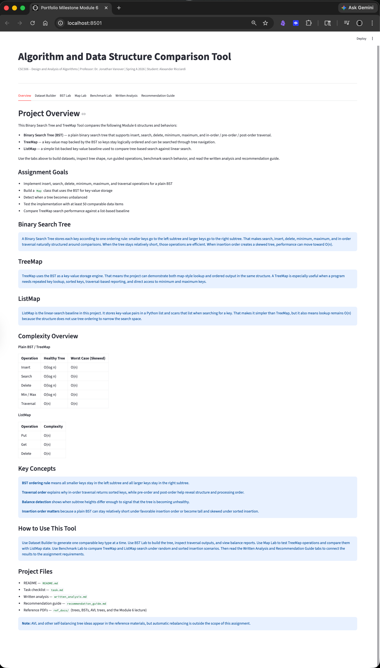

Dataset Builder

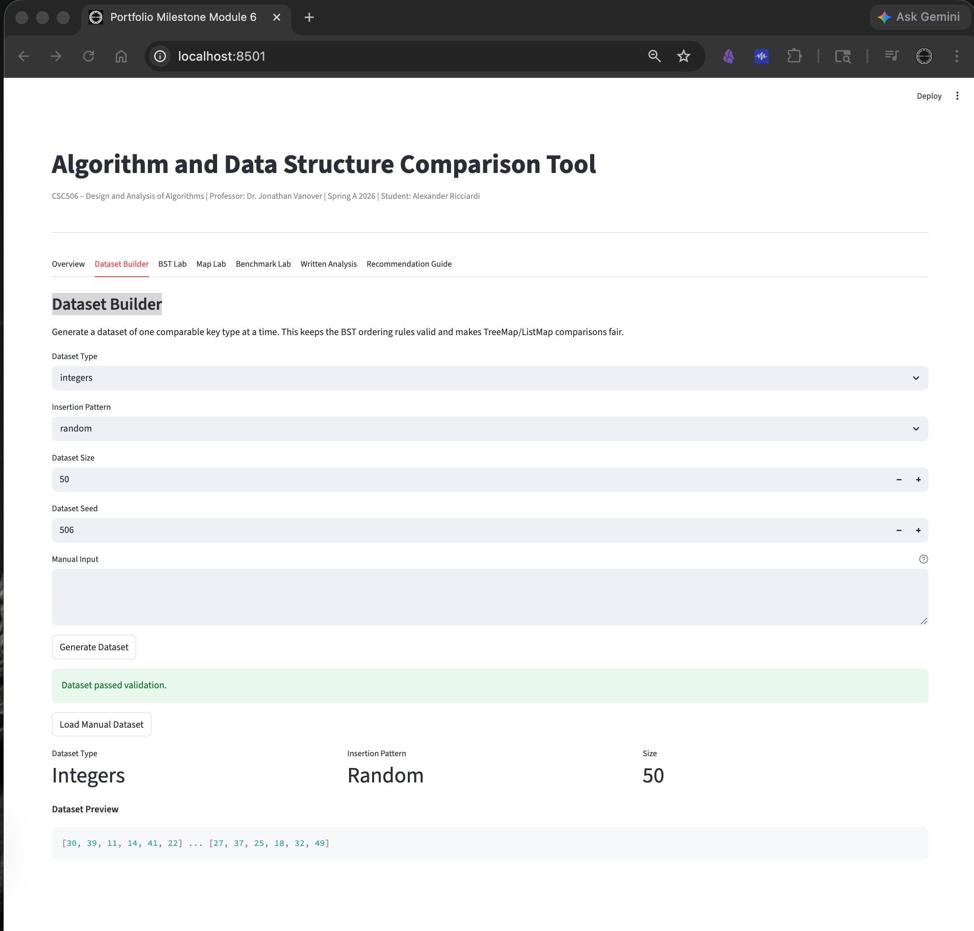

BST Lab – Landing Page

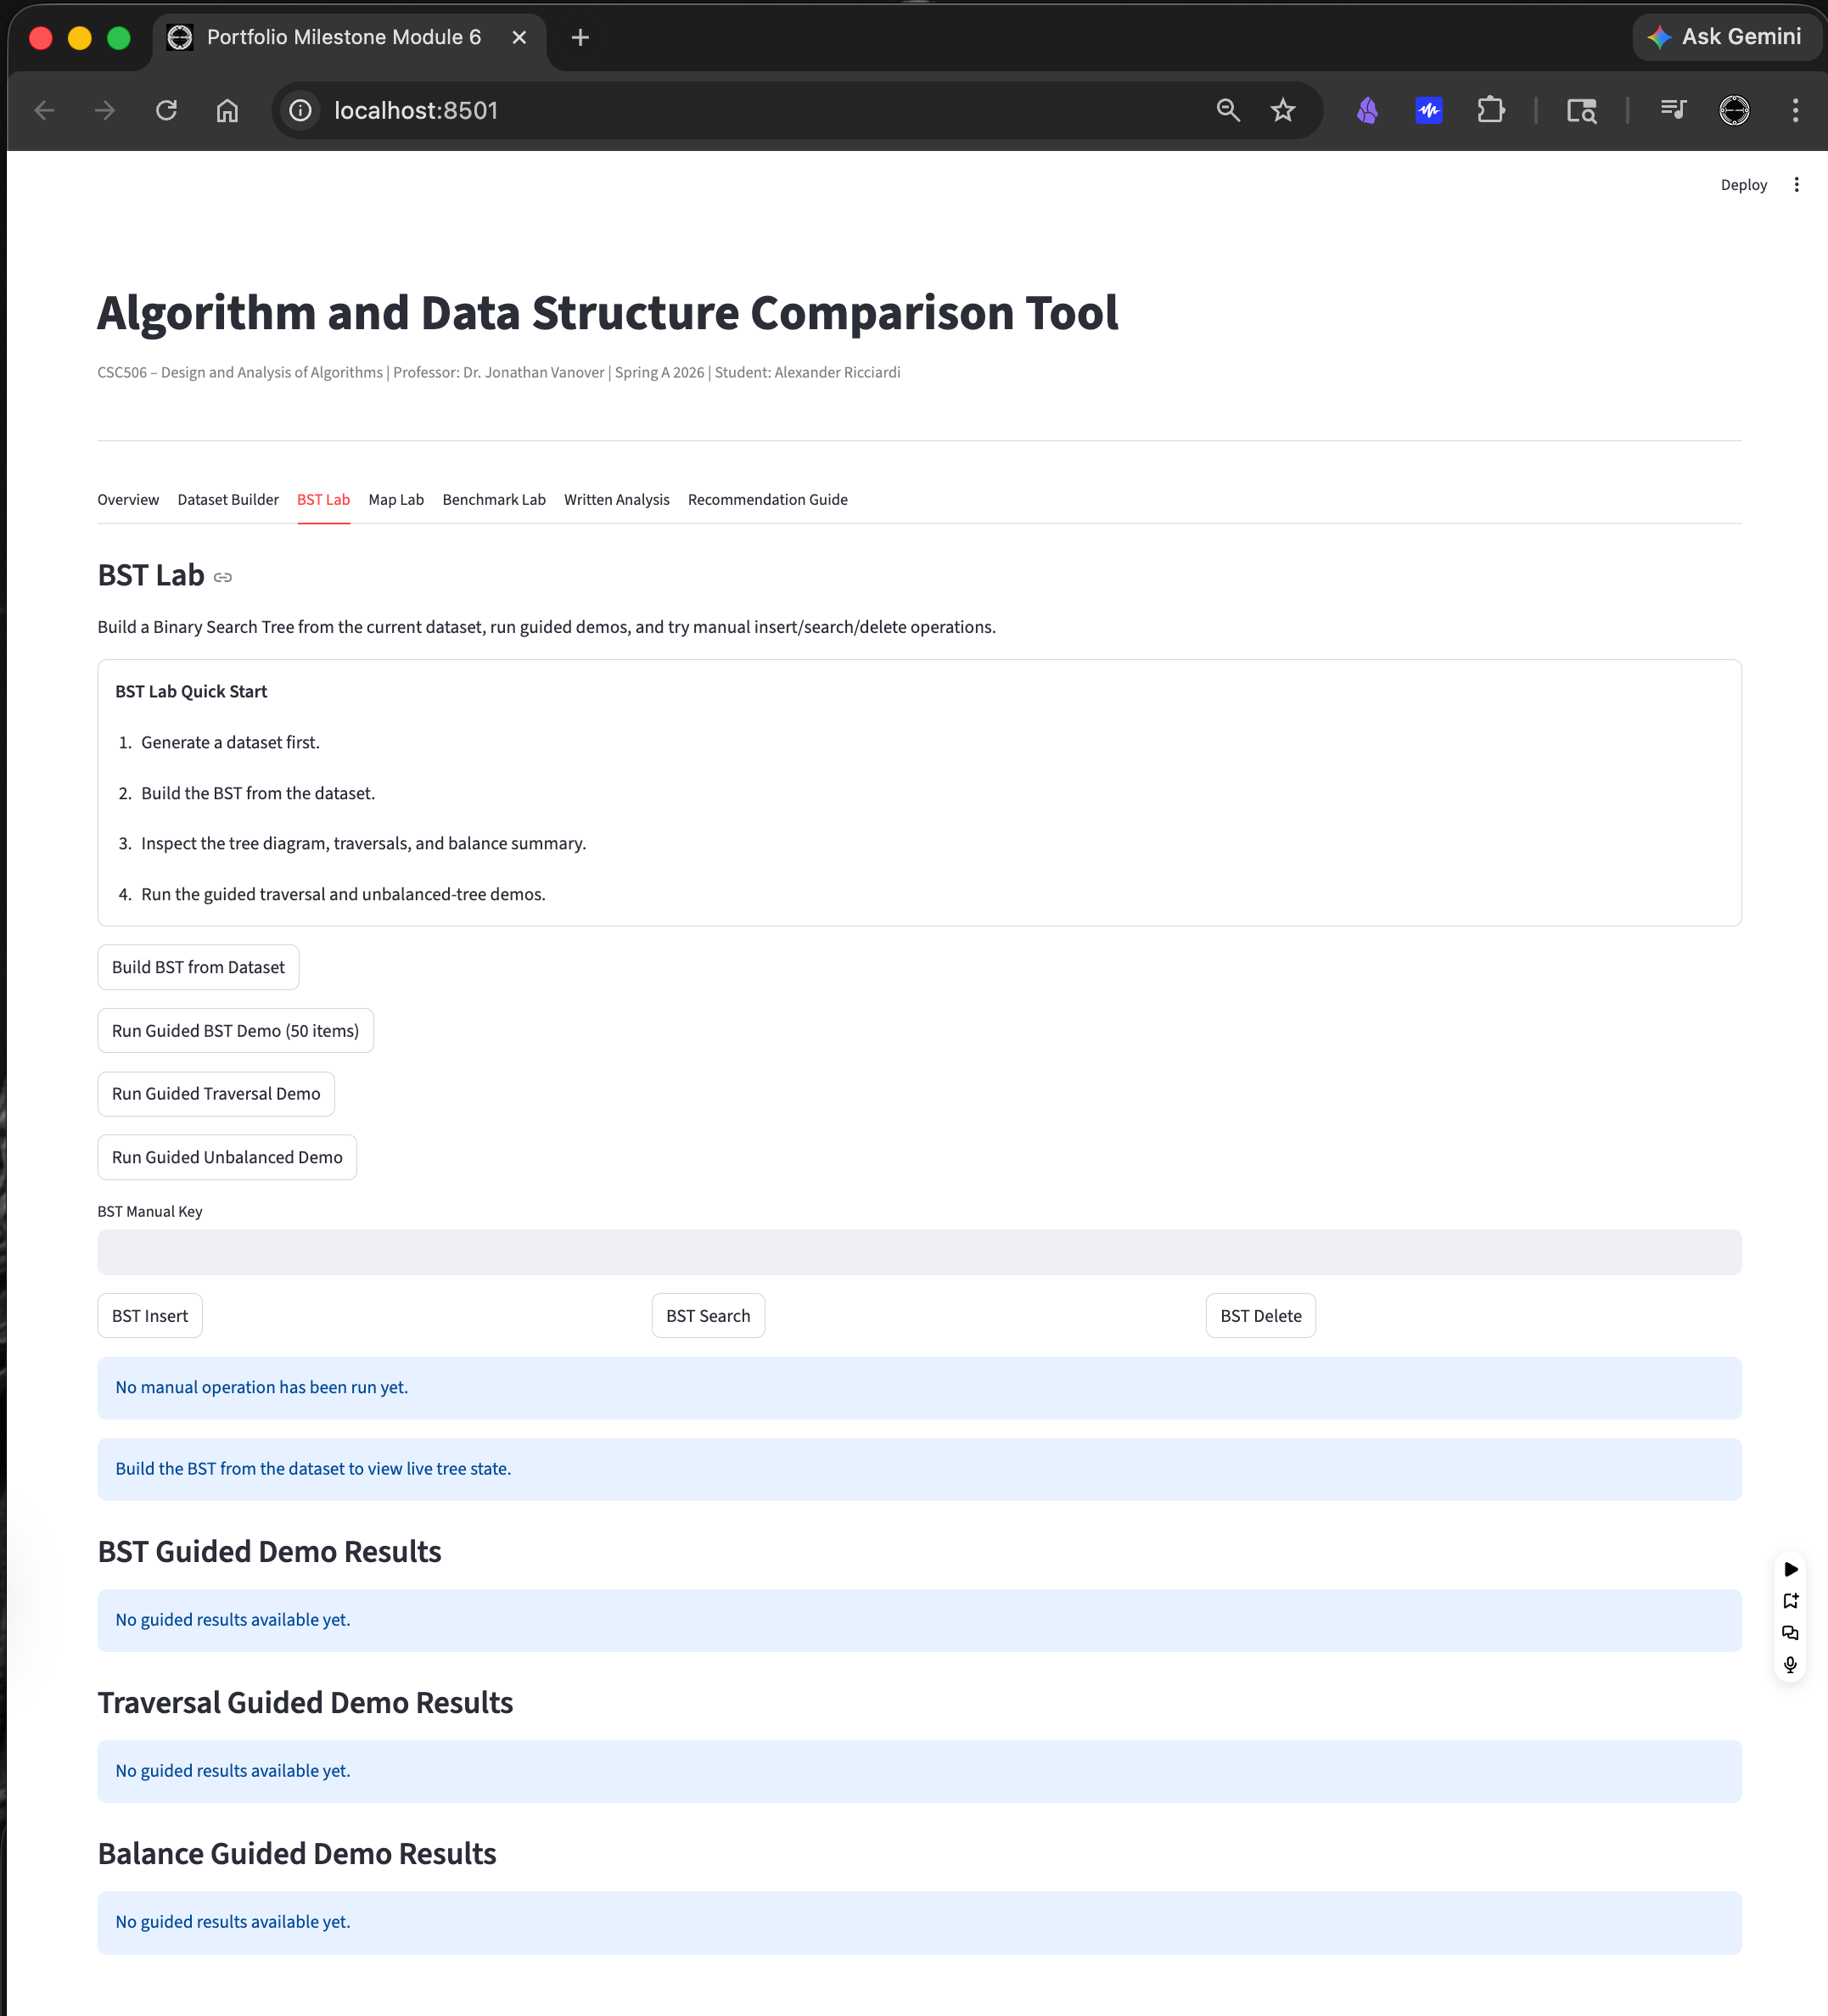

BST Lab – Build BTS from Dataset

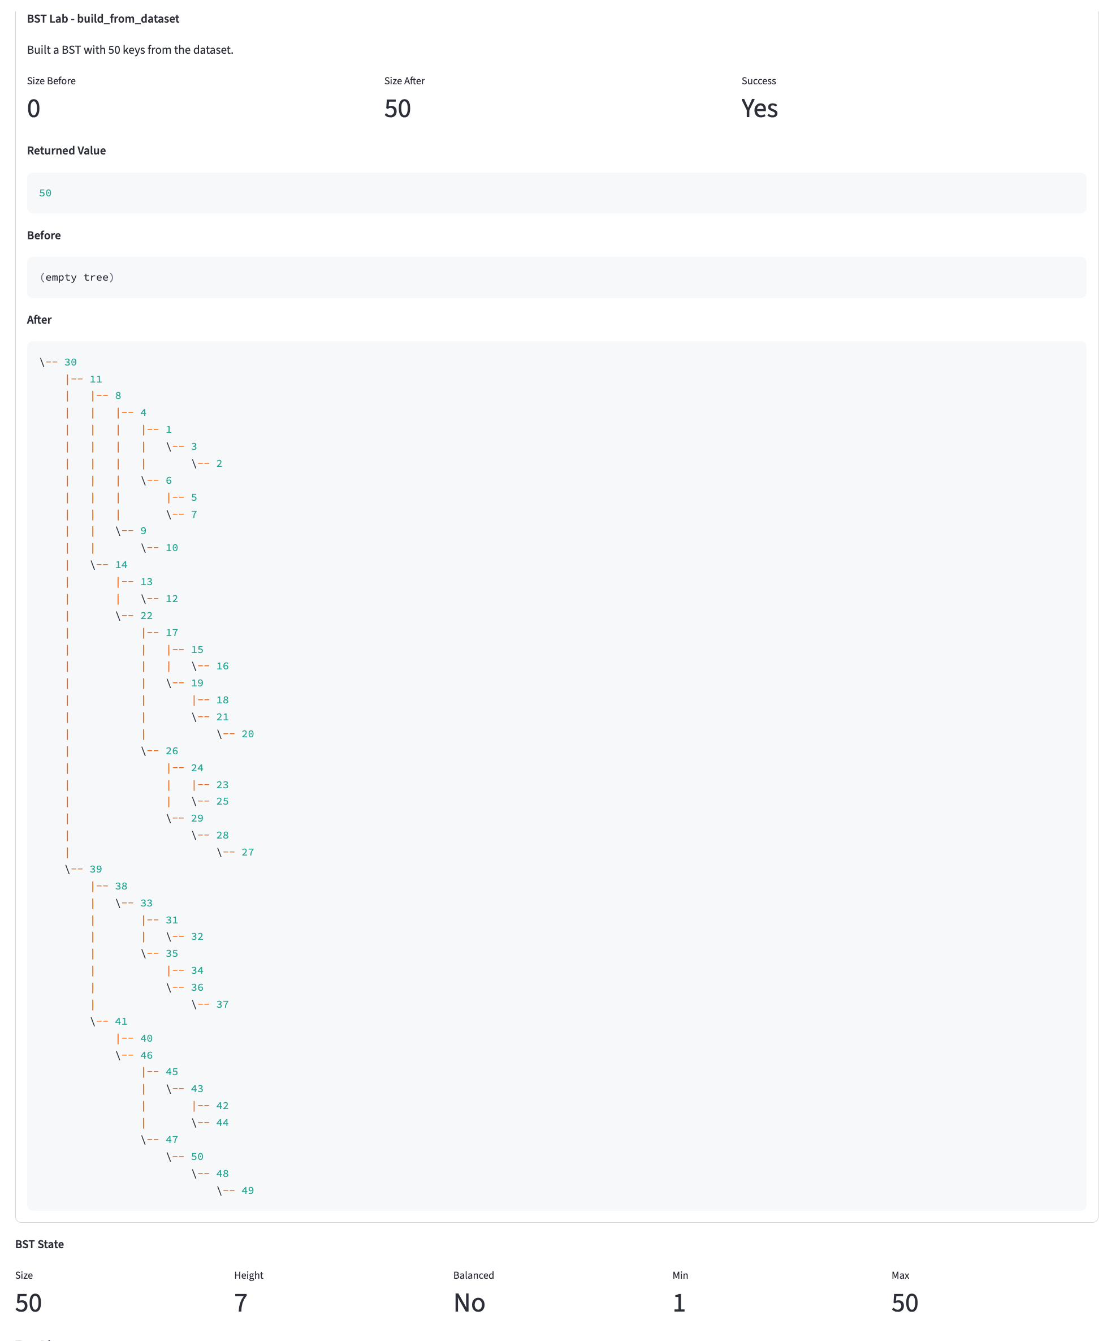
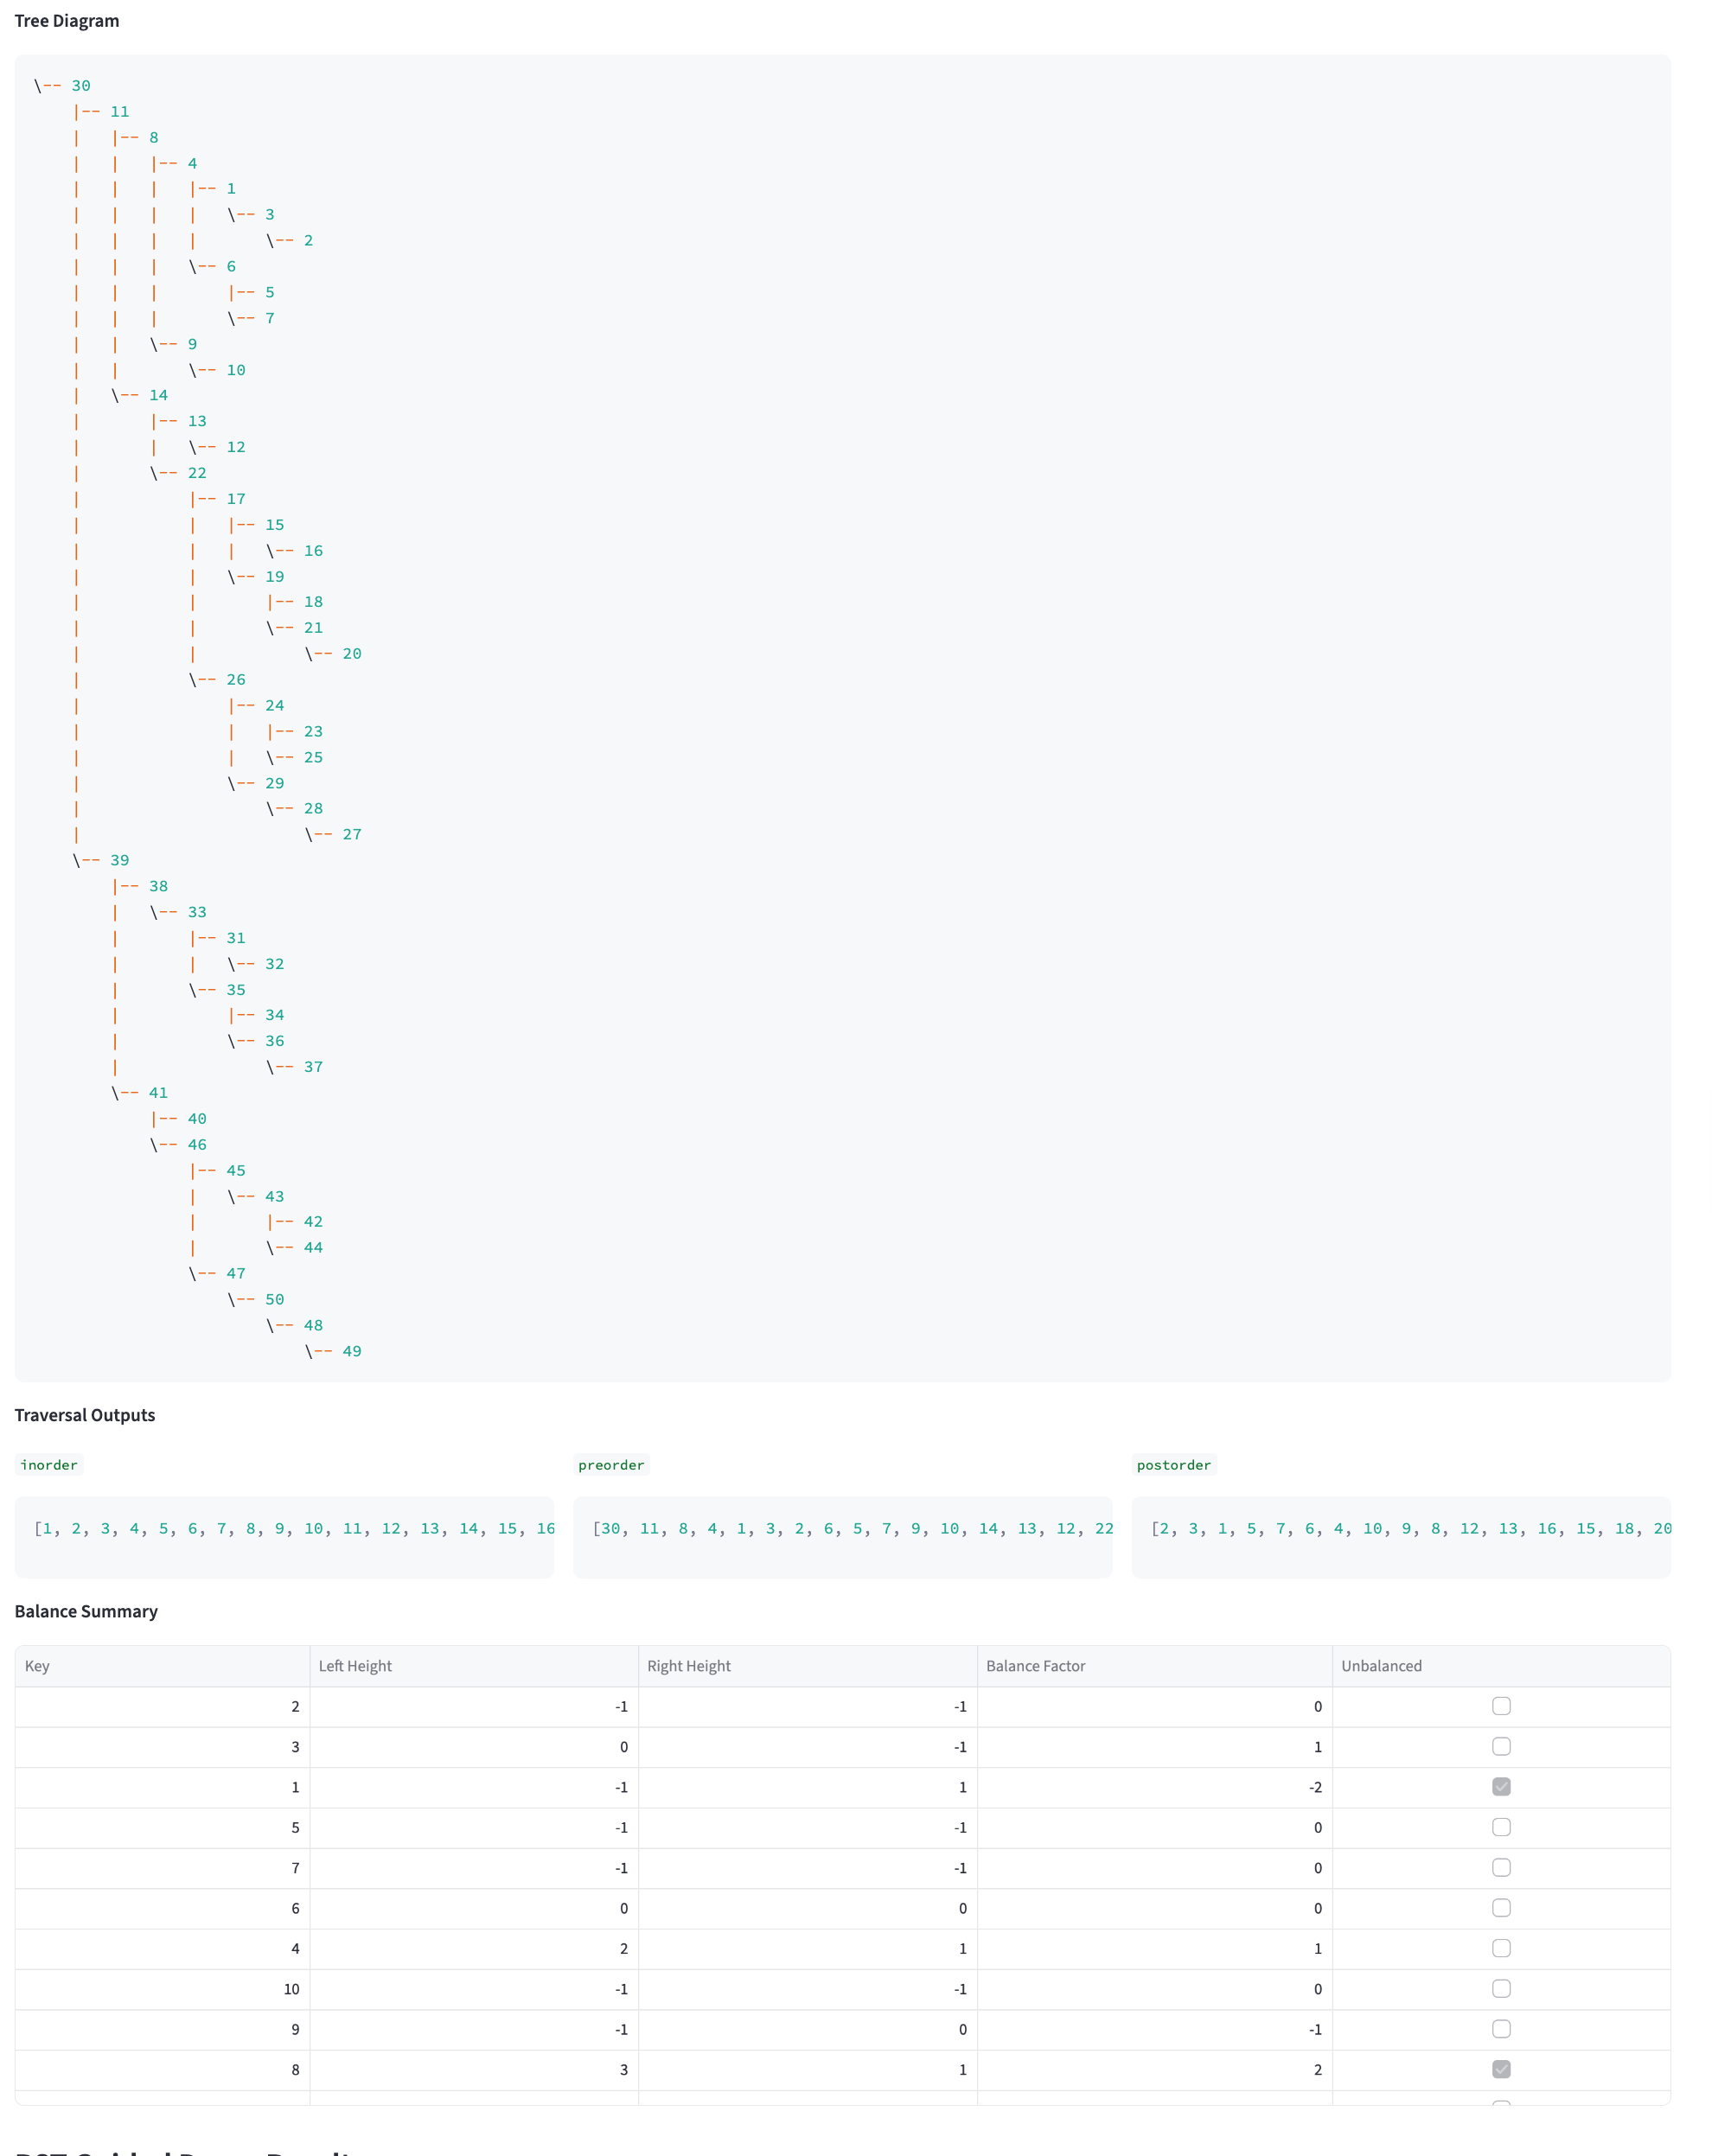

BST Lab – BST Guided Demo Results

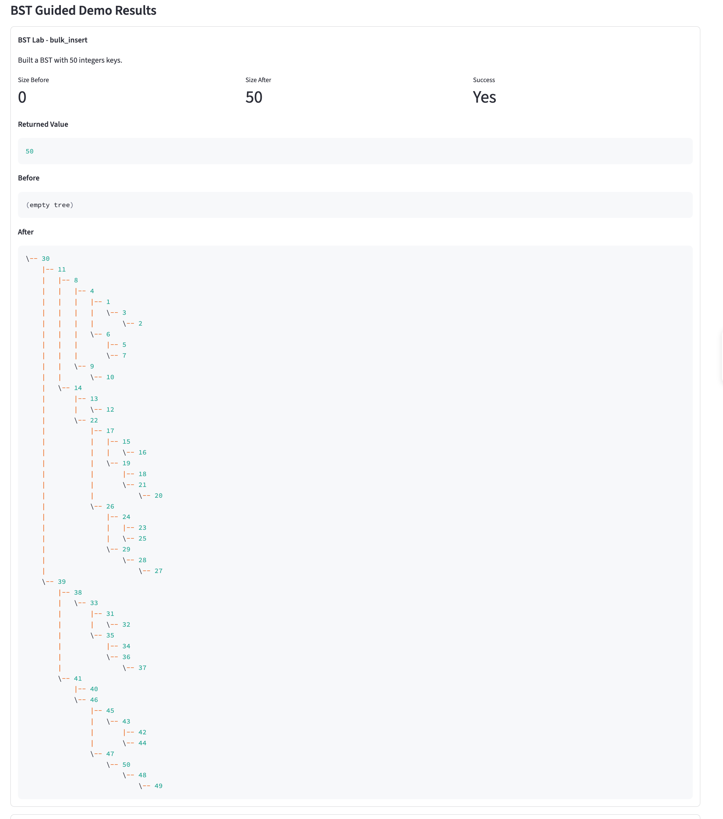
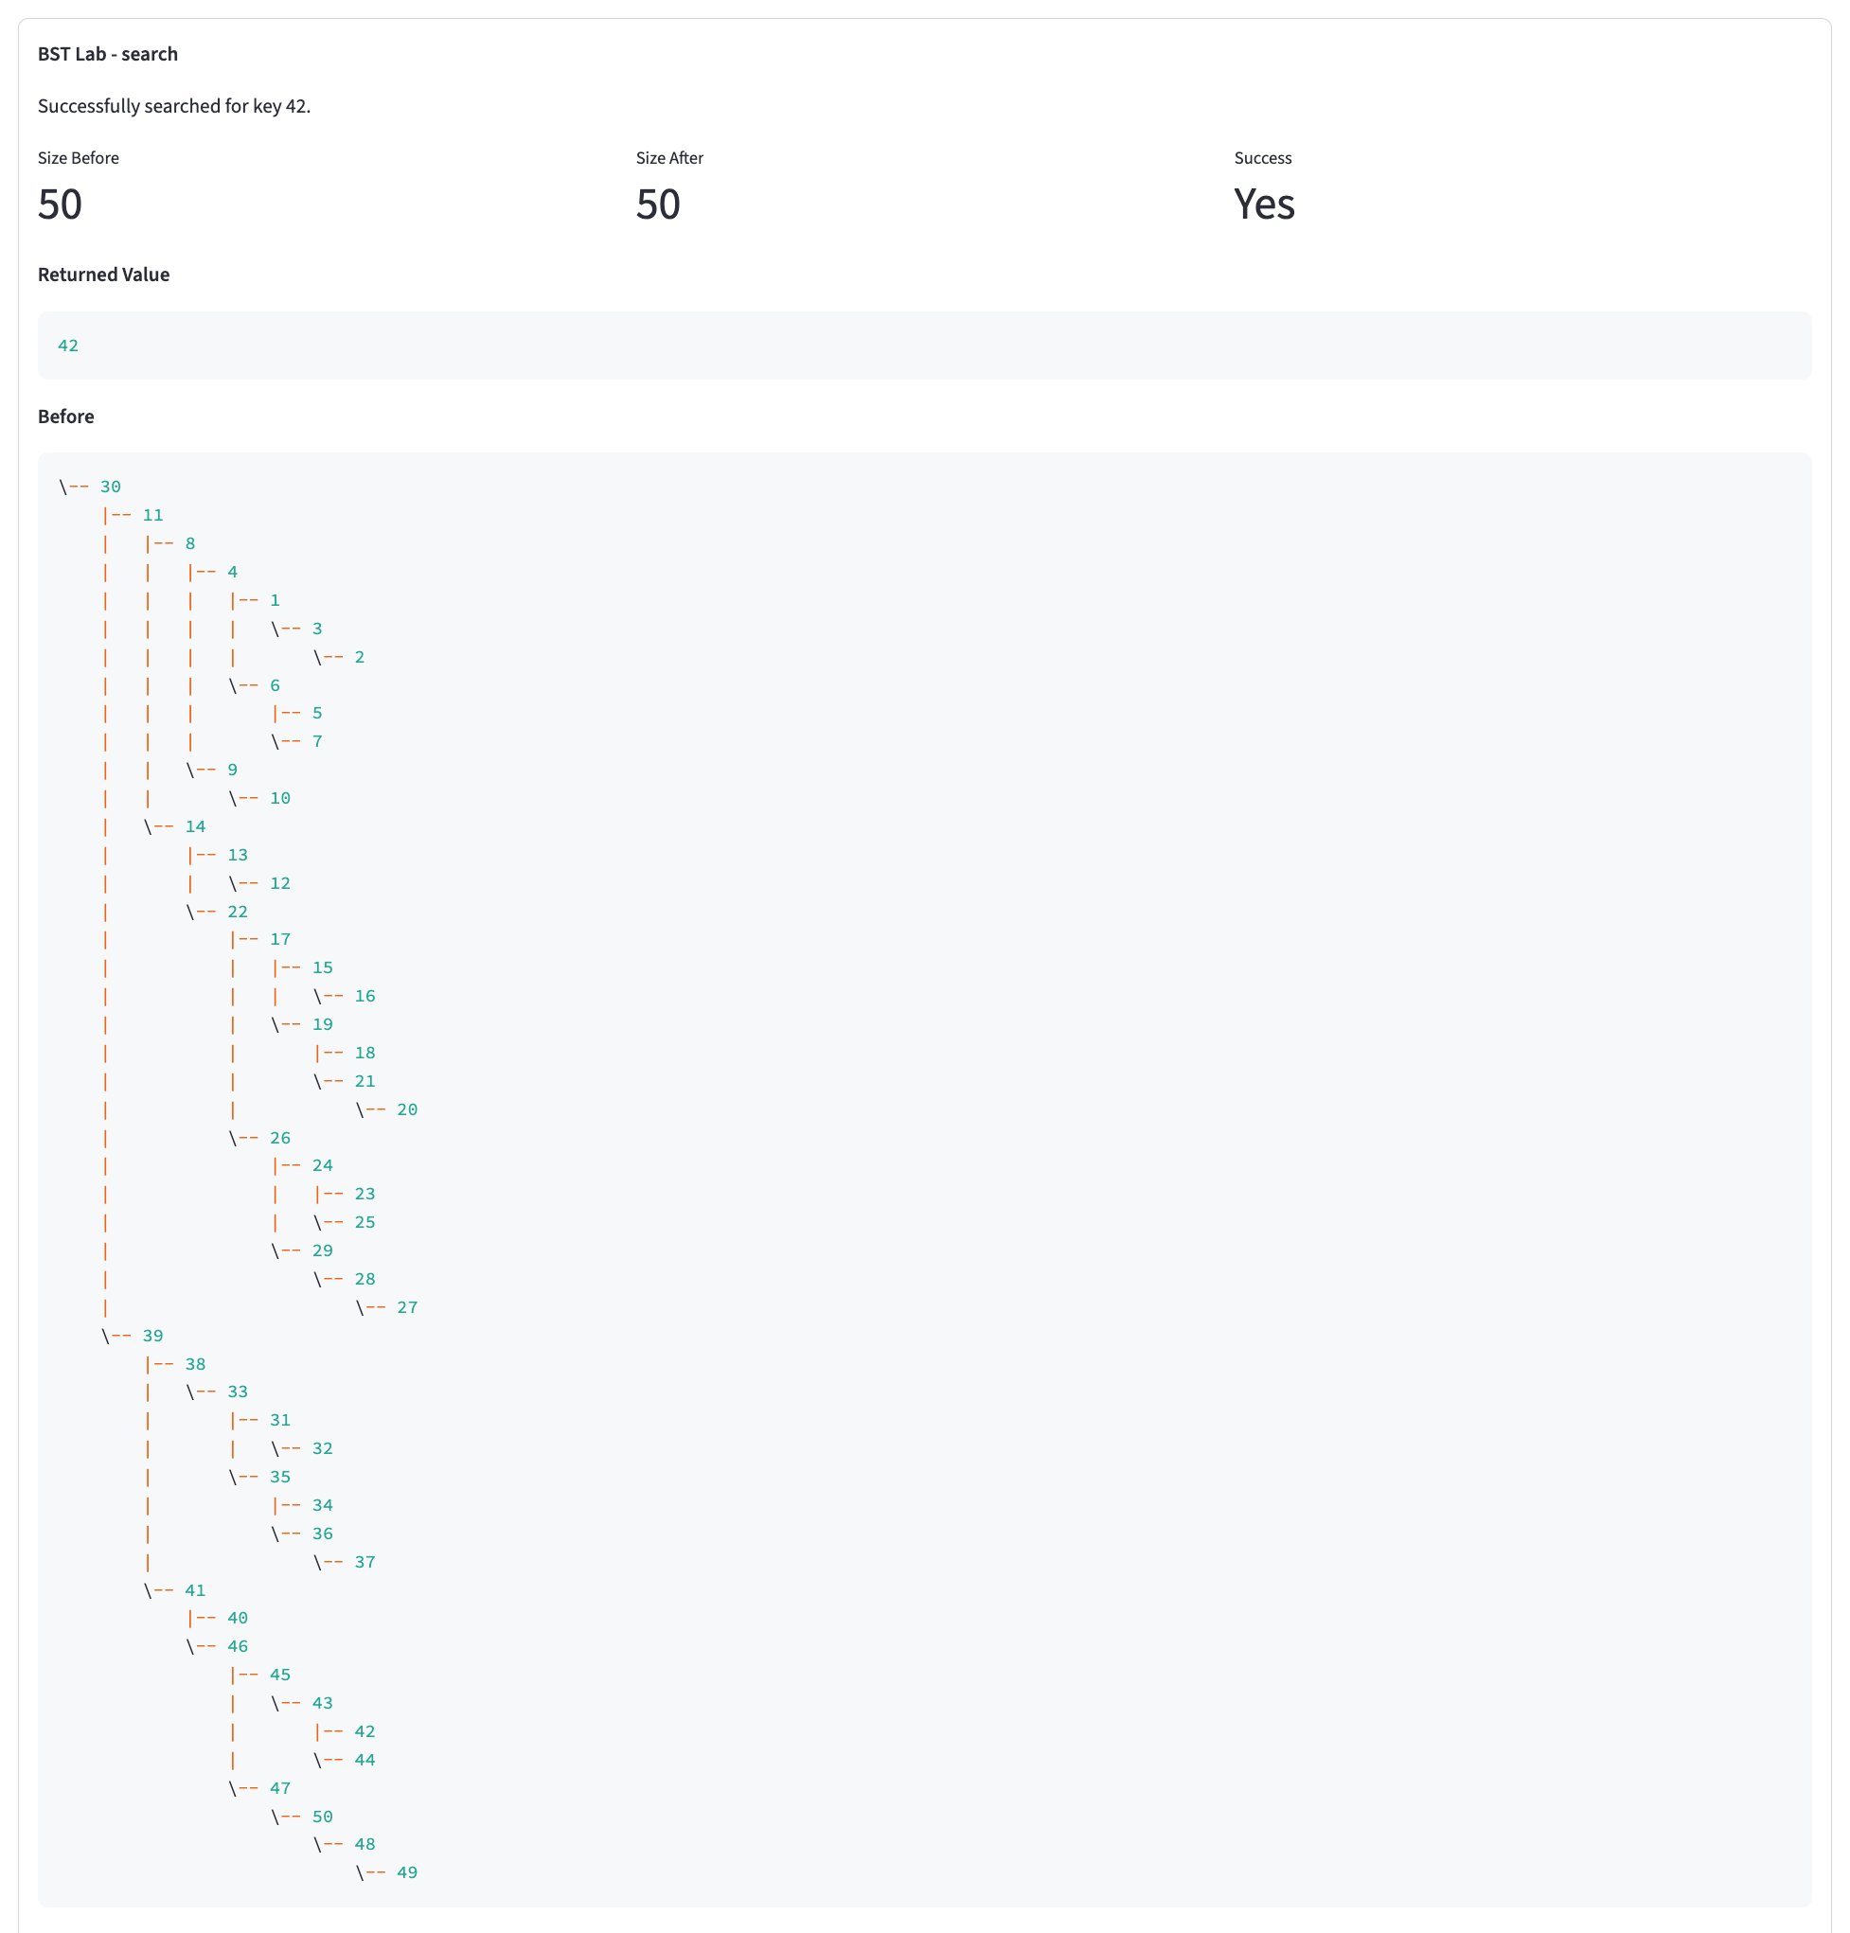

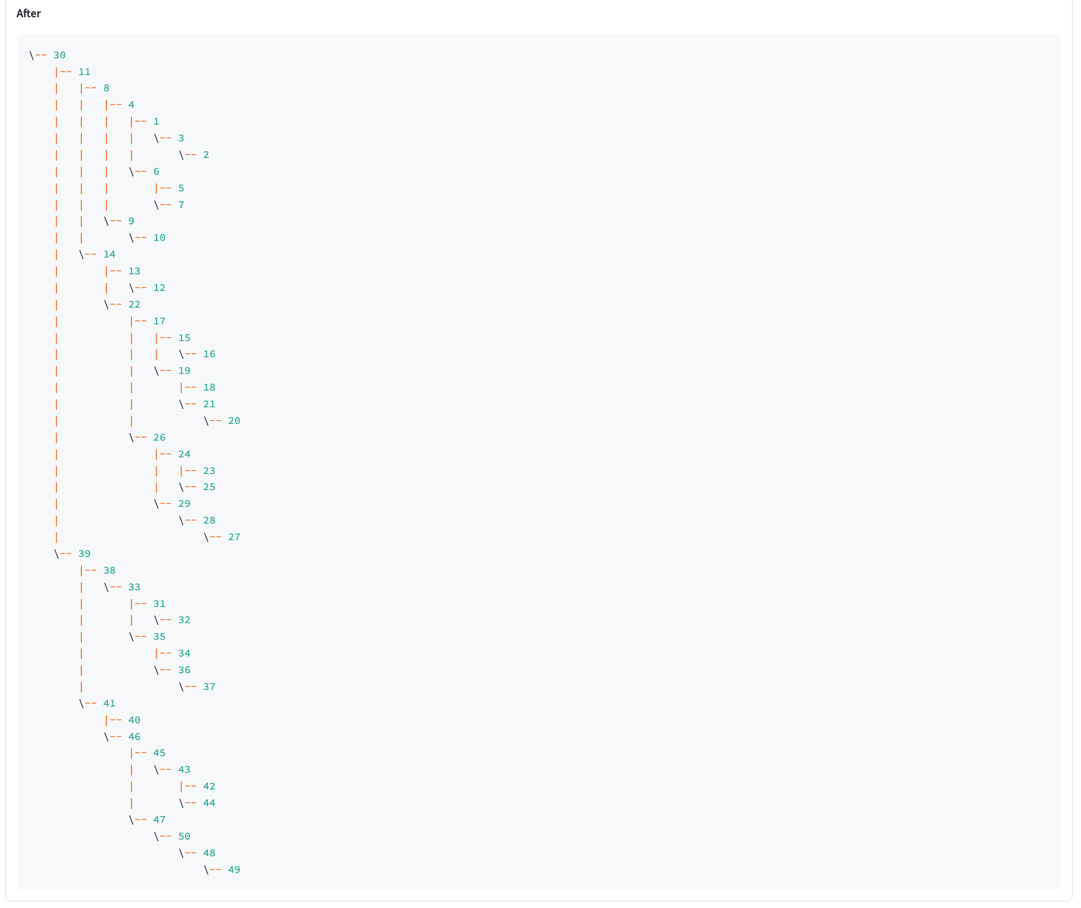

See next page

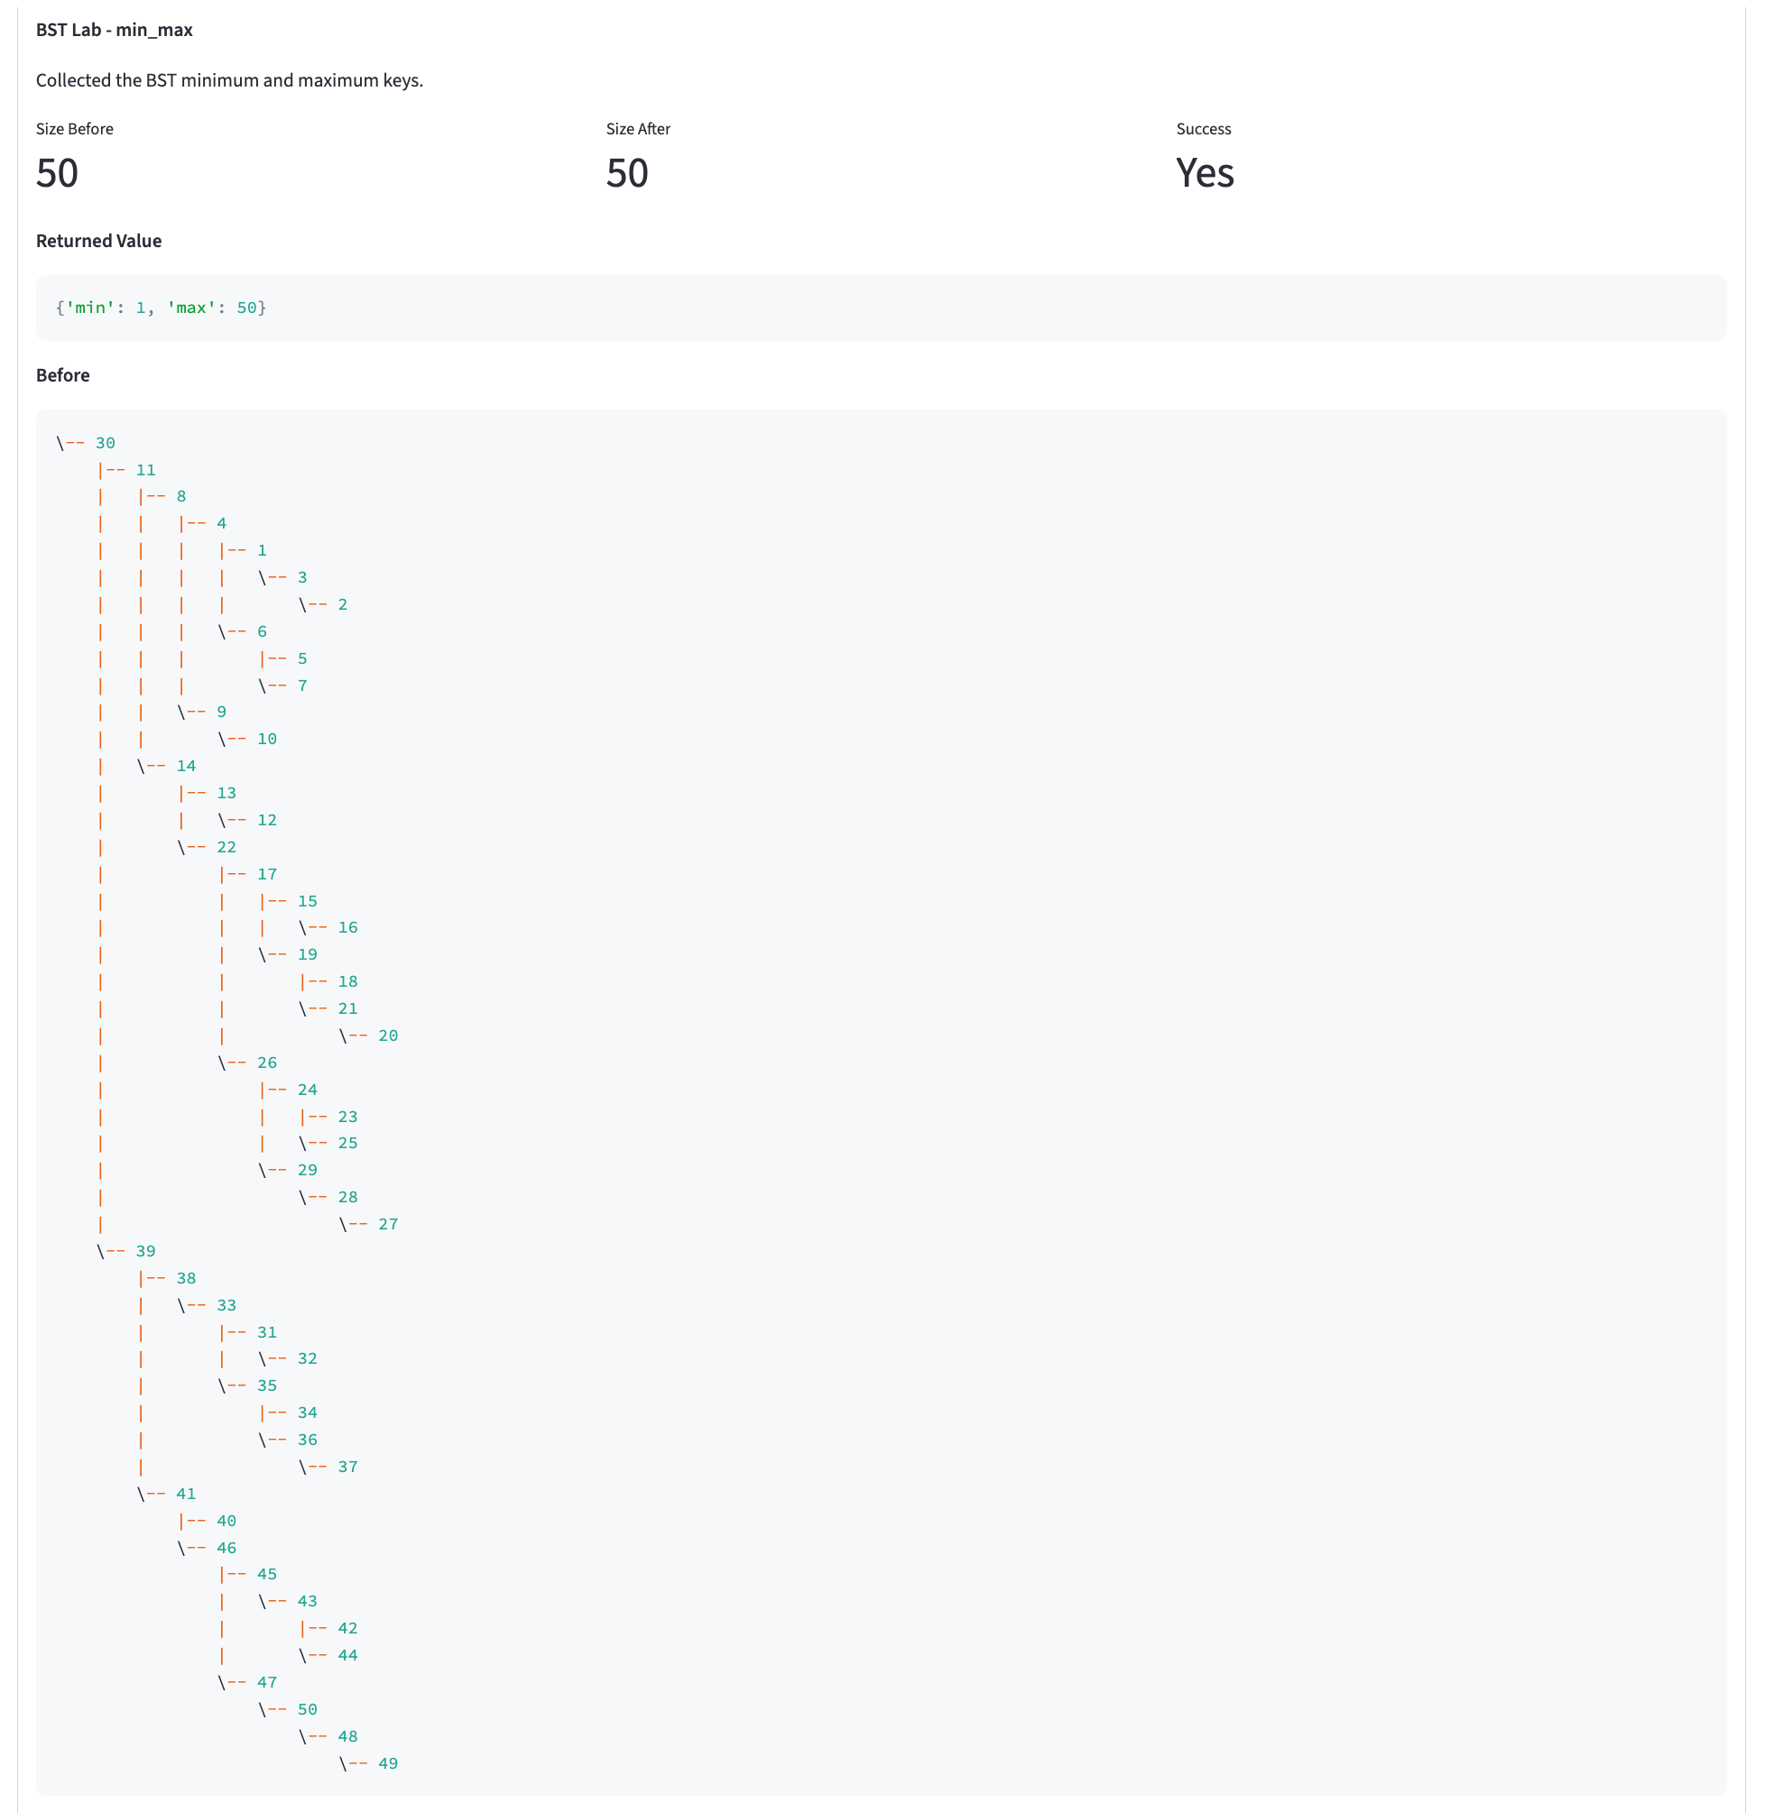

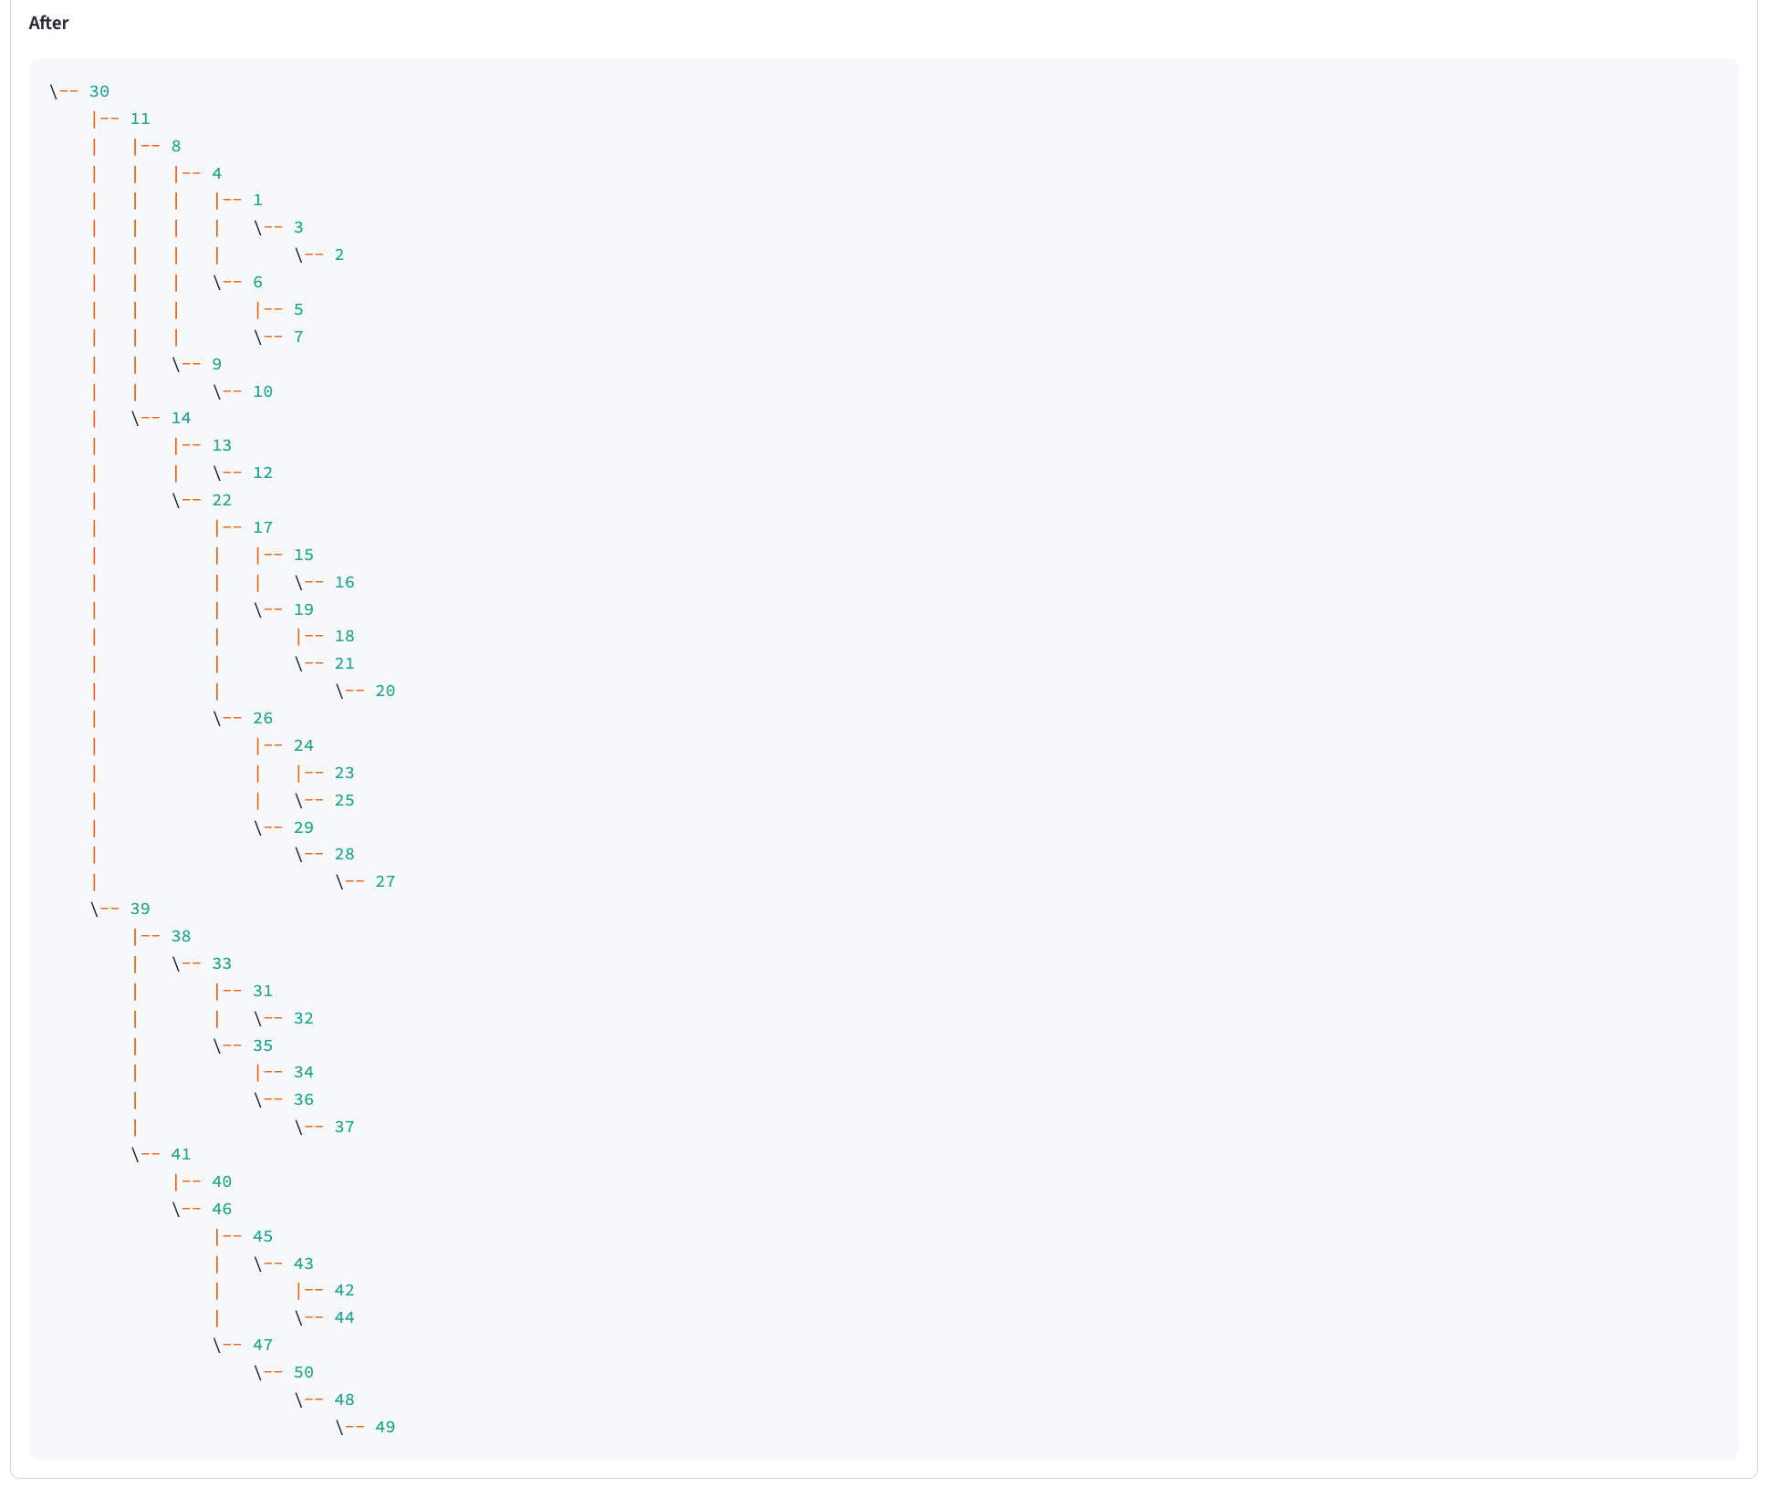

See next page

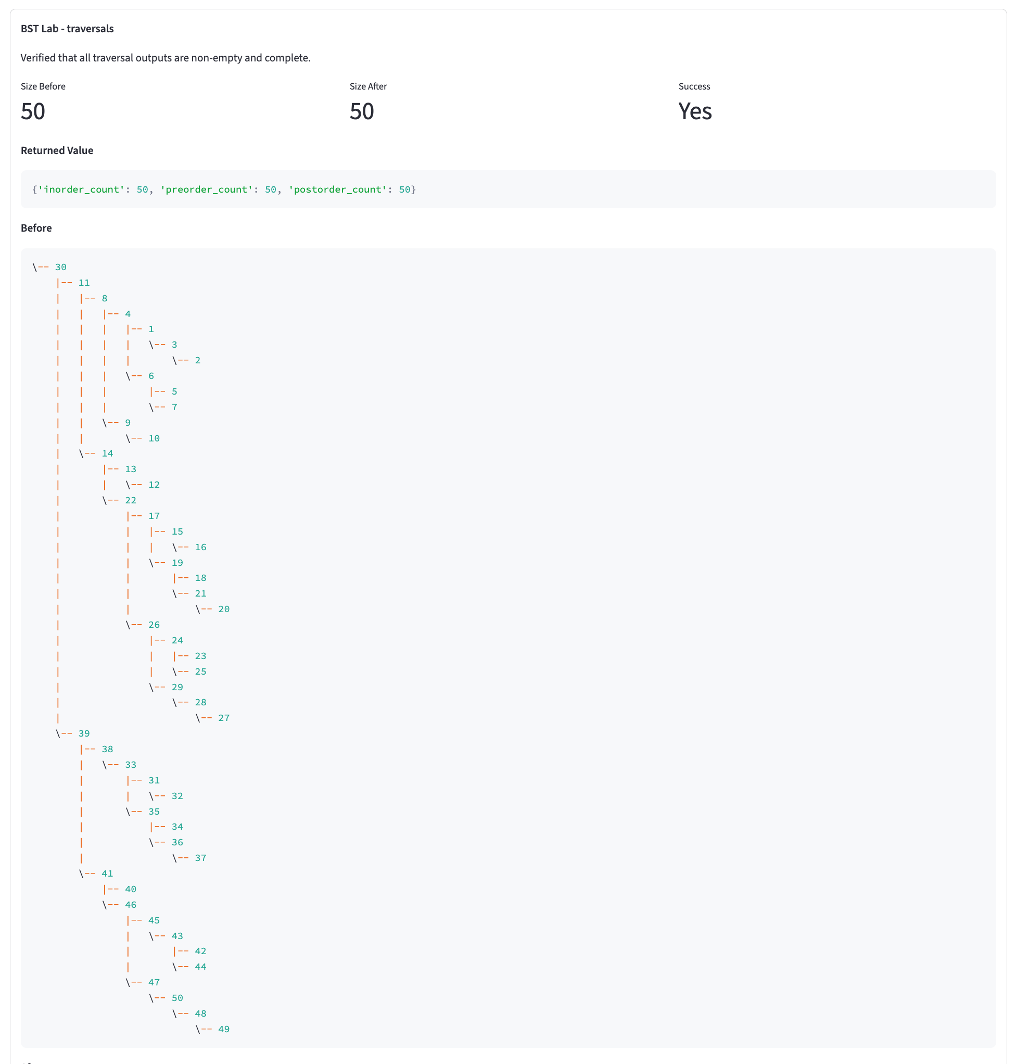

See next page
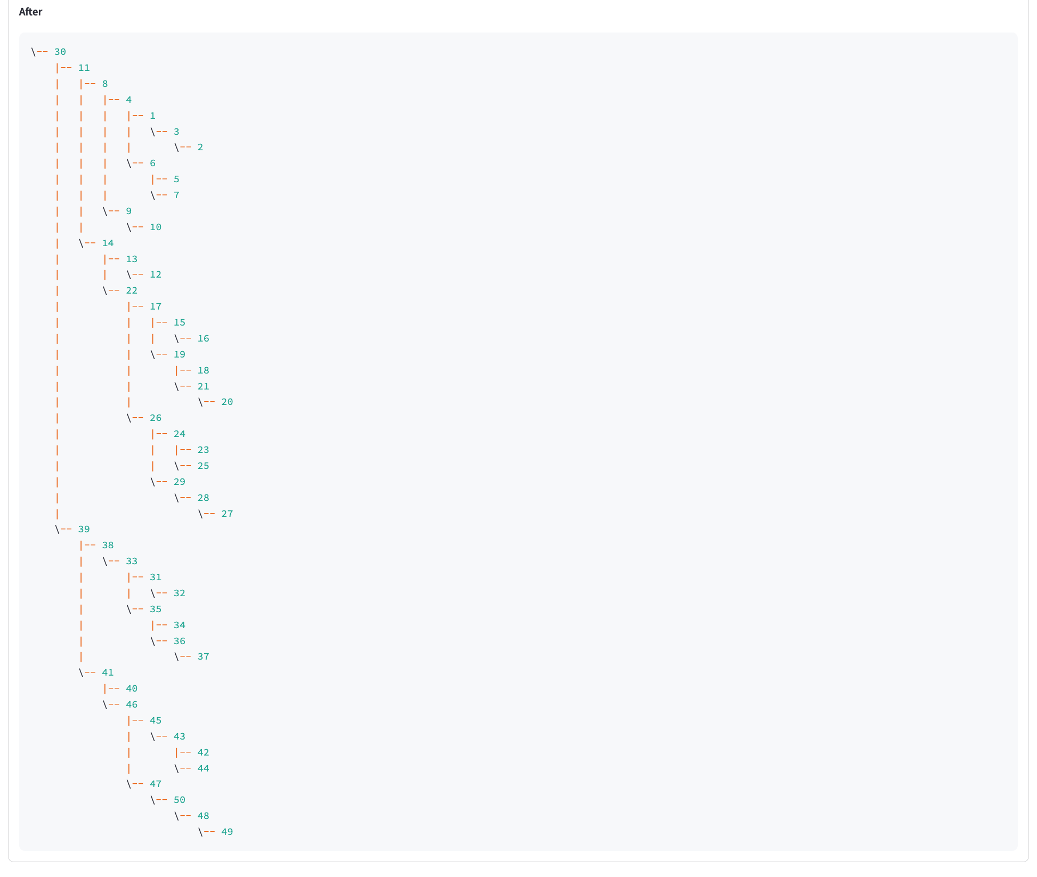

See next page

BST Lab – Traversal Guided Demo Results
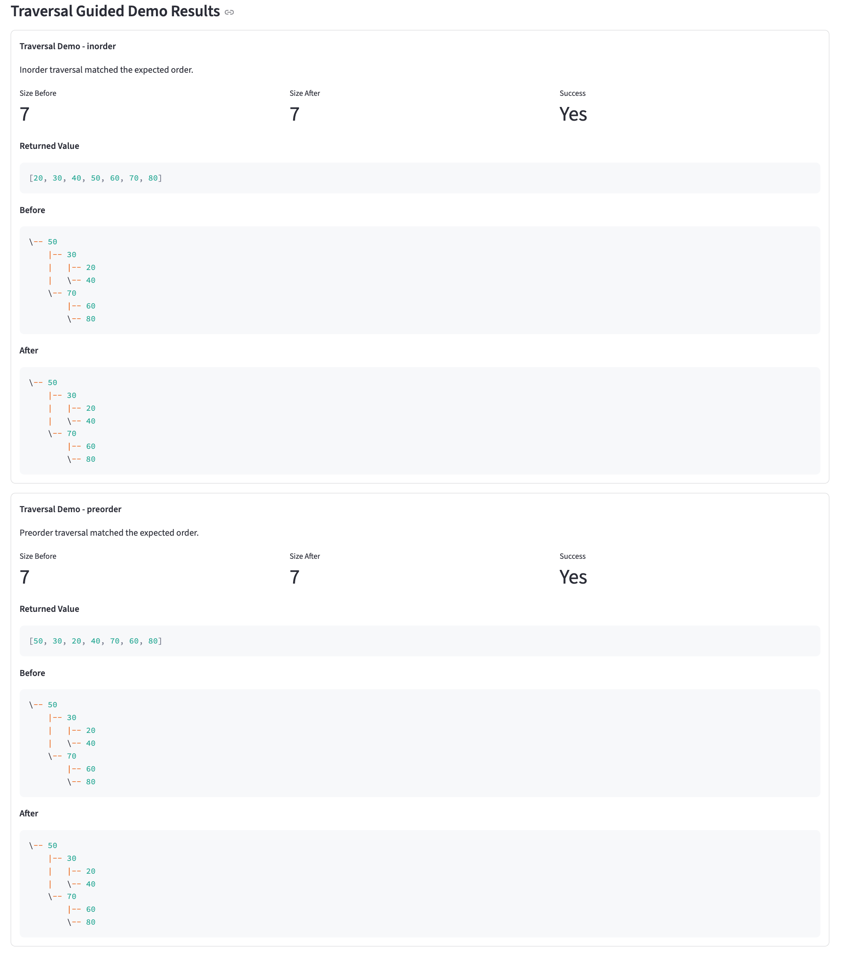
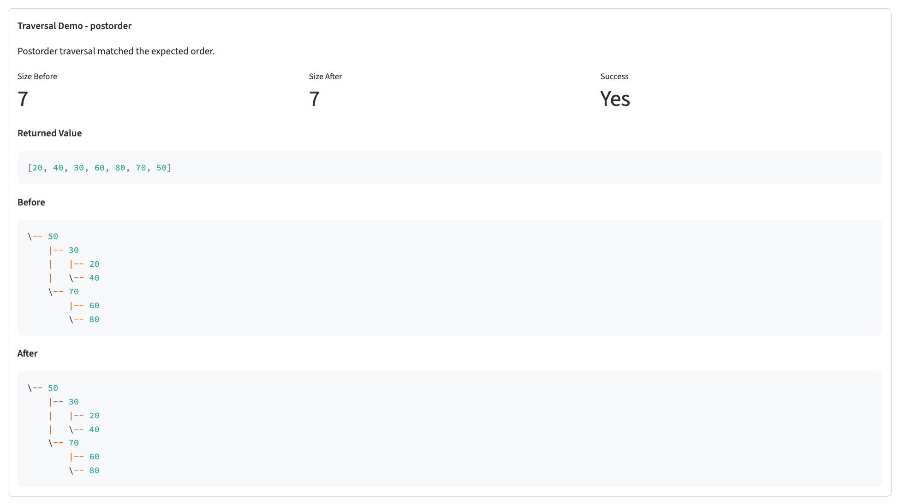

See next page

BST Lab – Balance Guided Demo Results

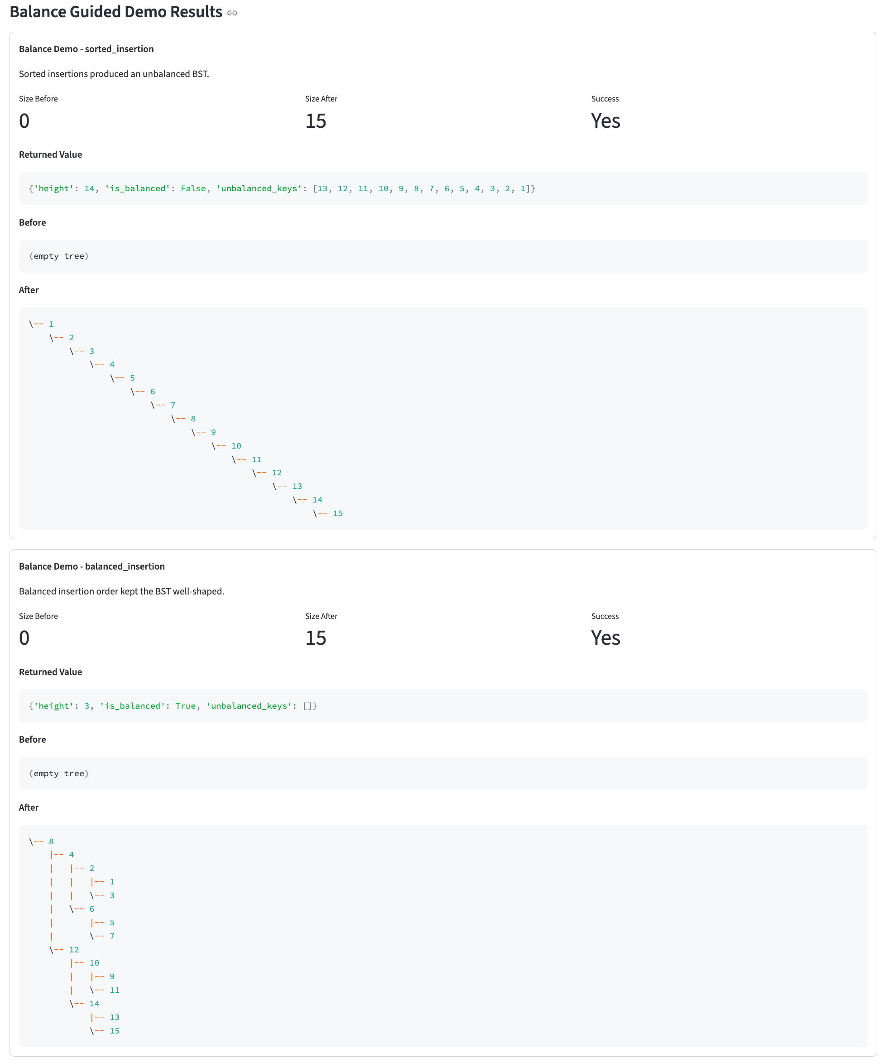
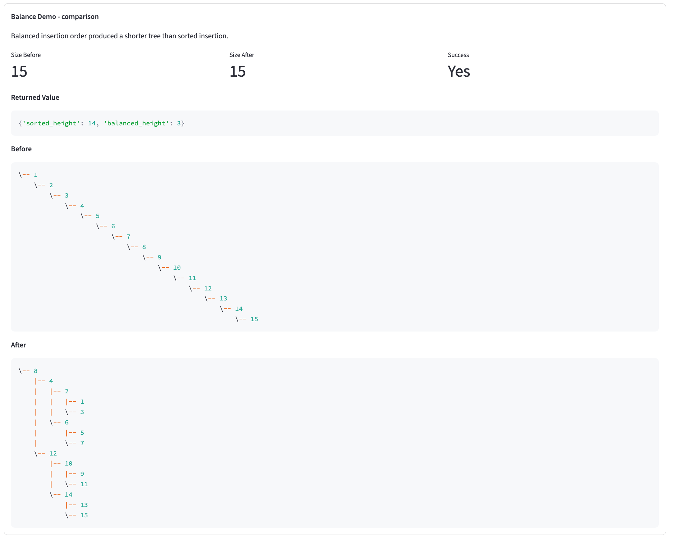

See next page

BST Lab – BST Manual Key

BTS Insert

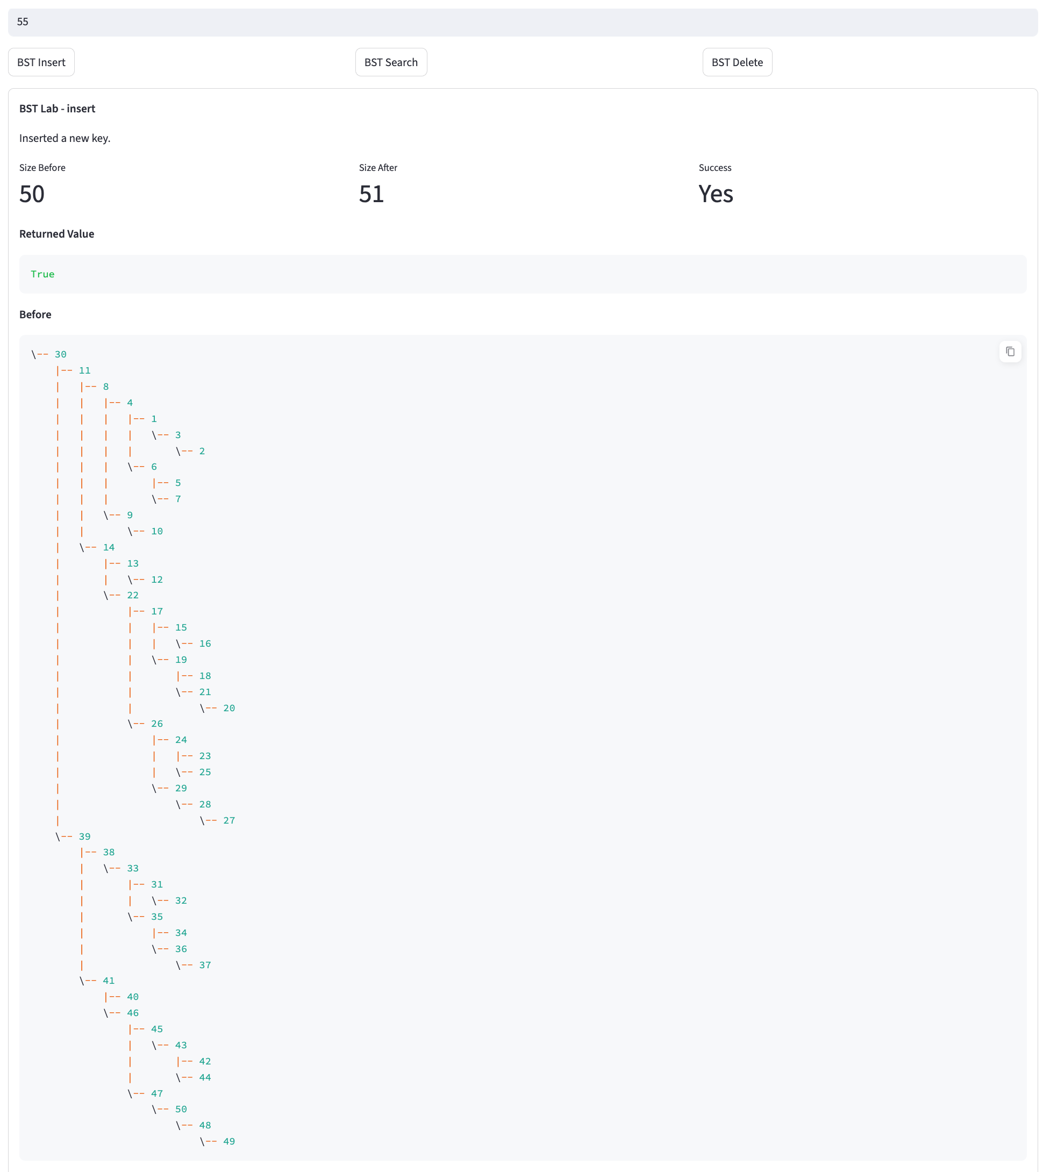
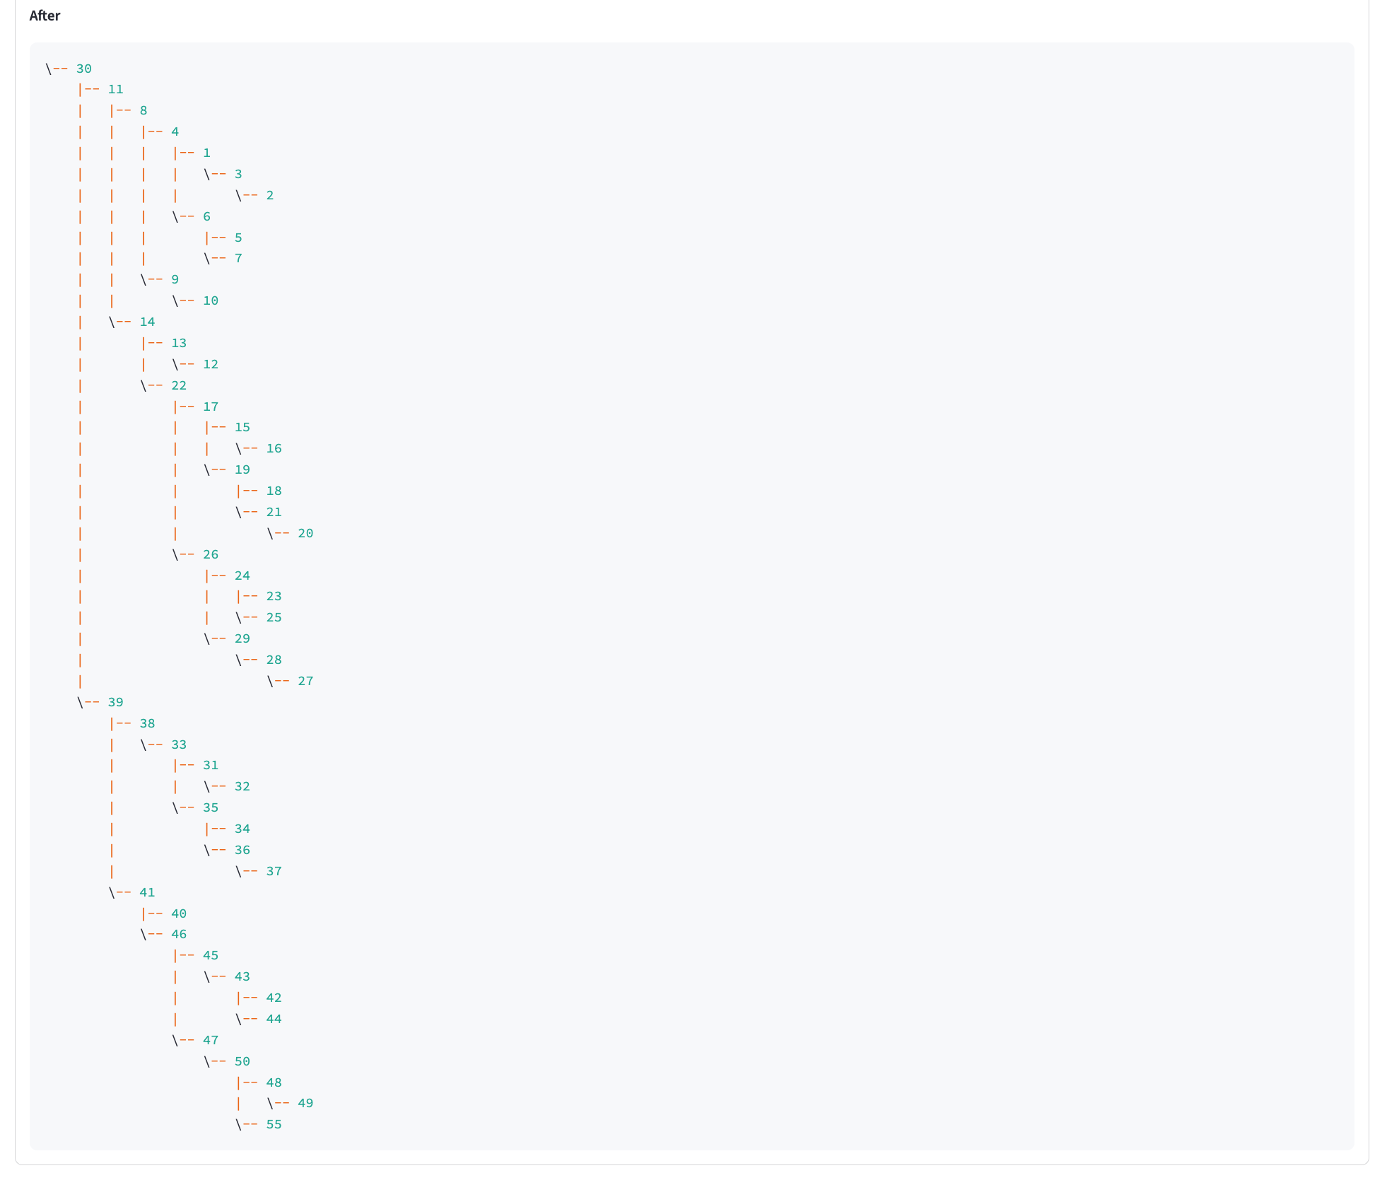

See next page

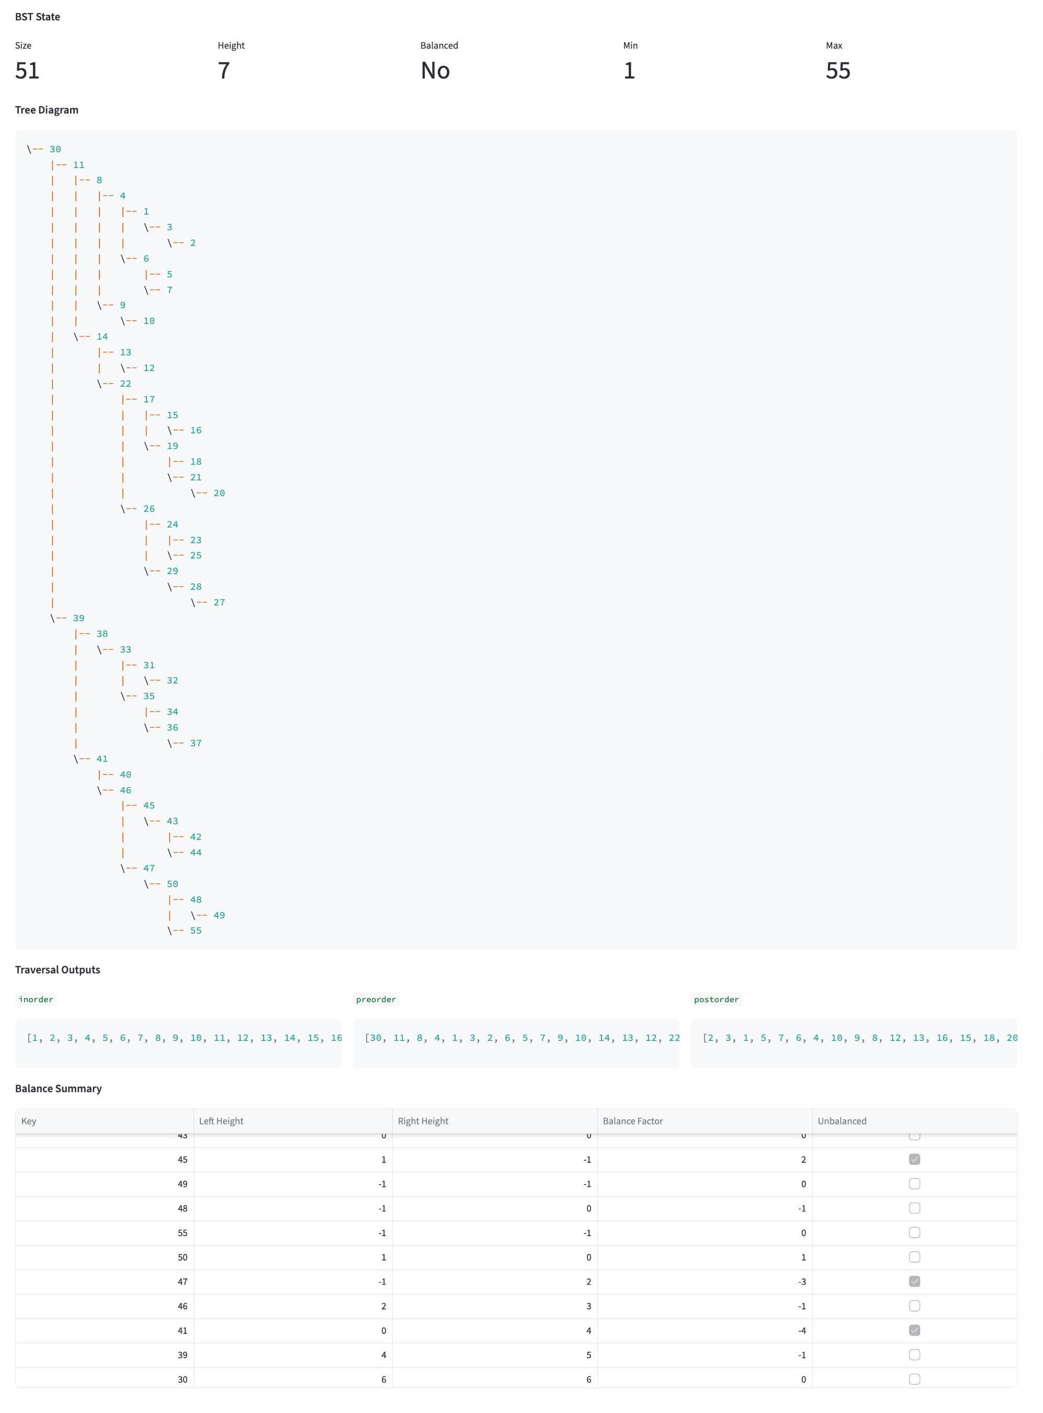
BTS Search

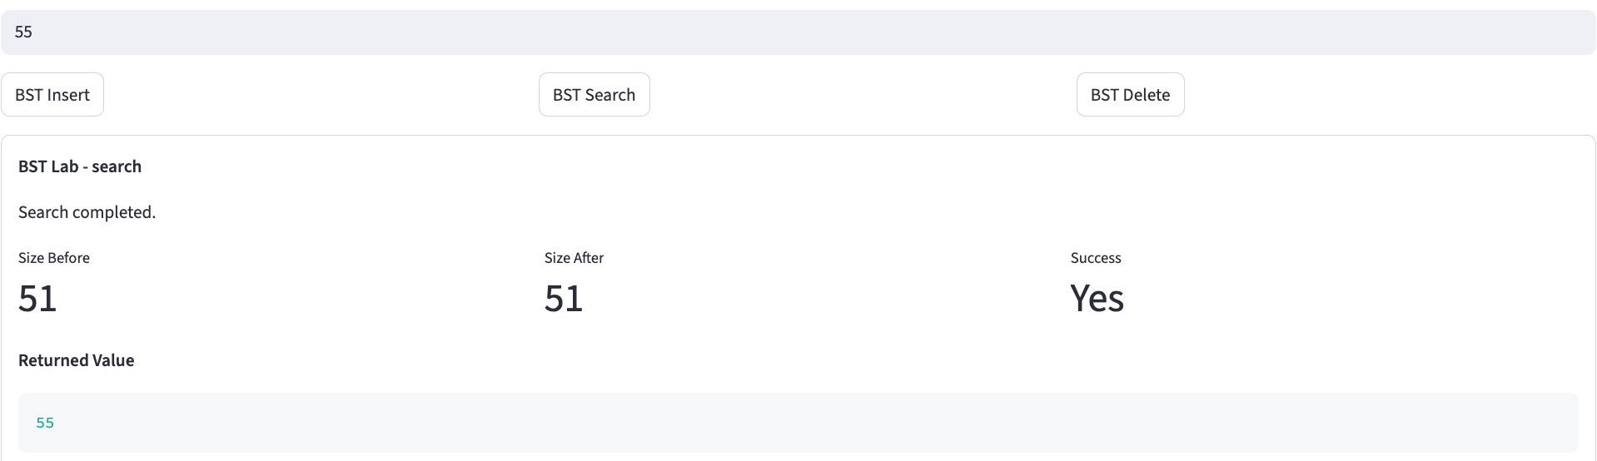

See next page

BTS Deleted
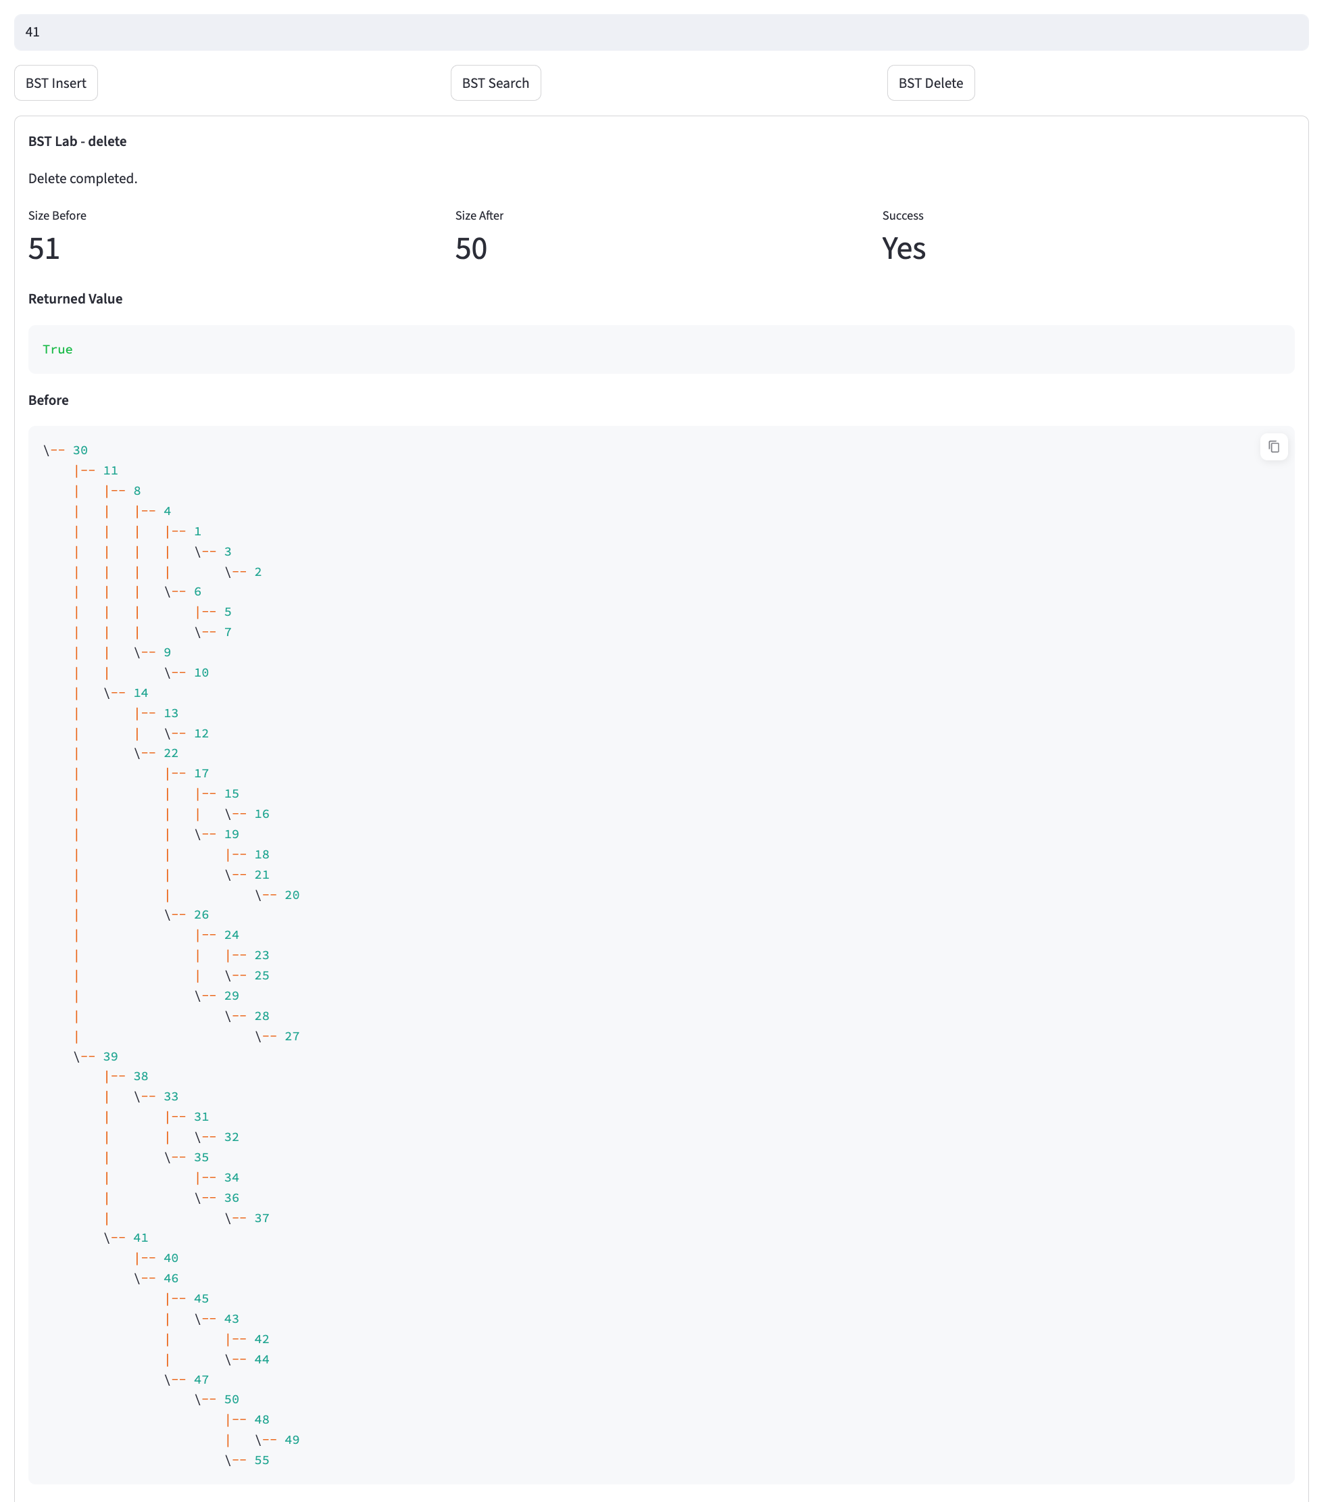
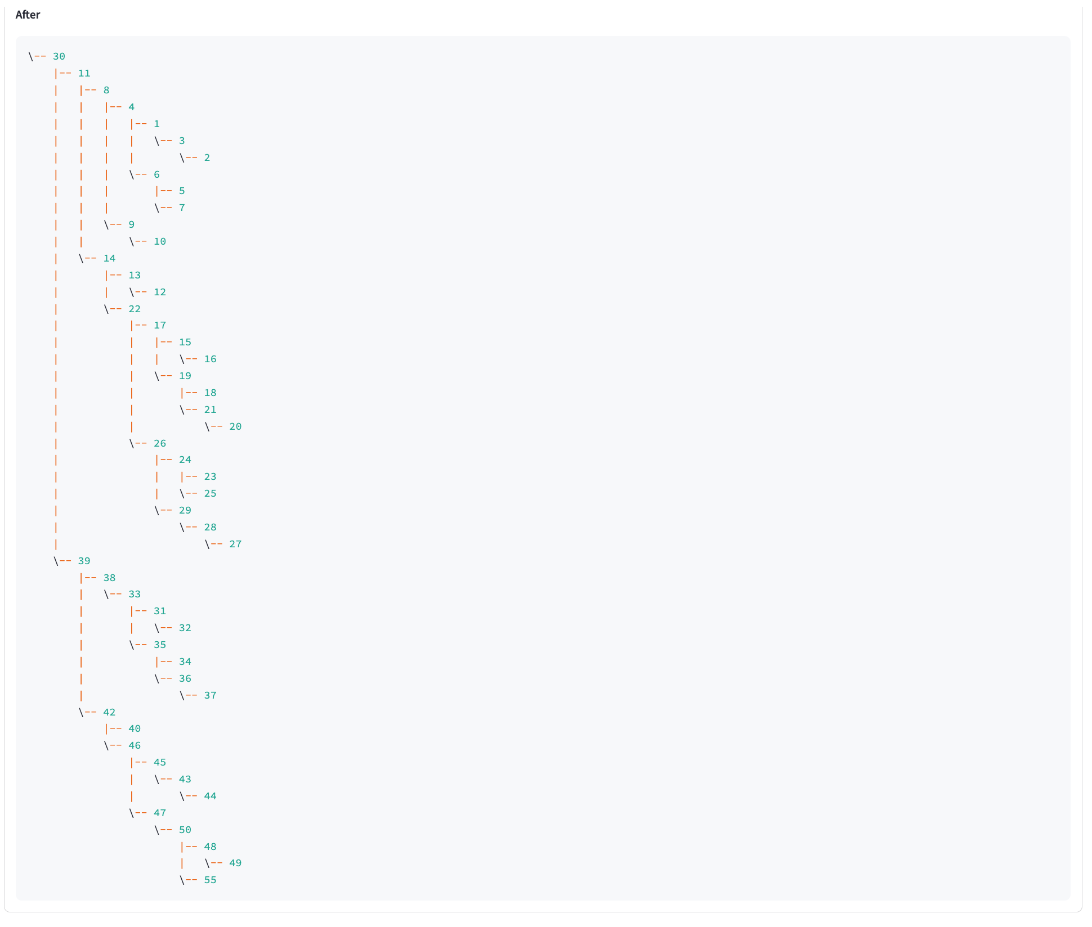

See next page

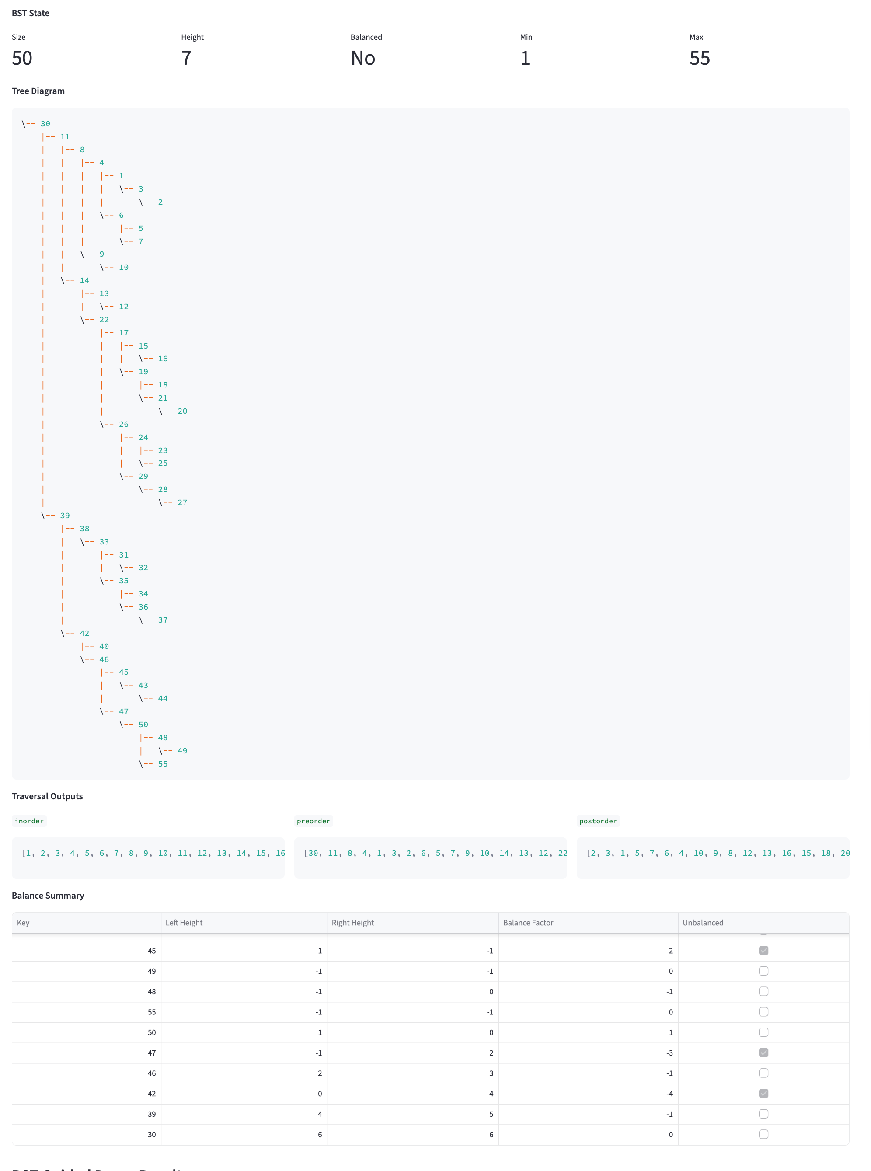

Map Lab – Landing Page
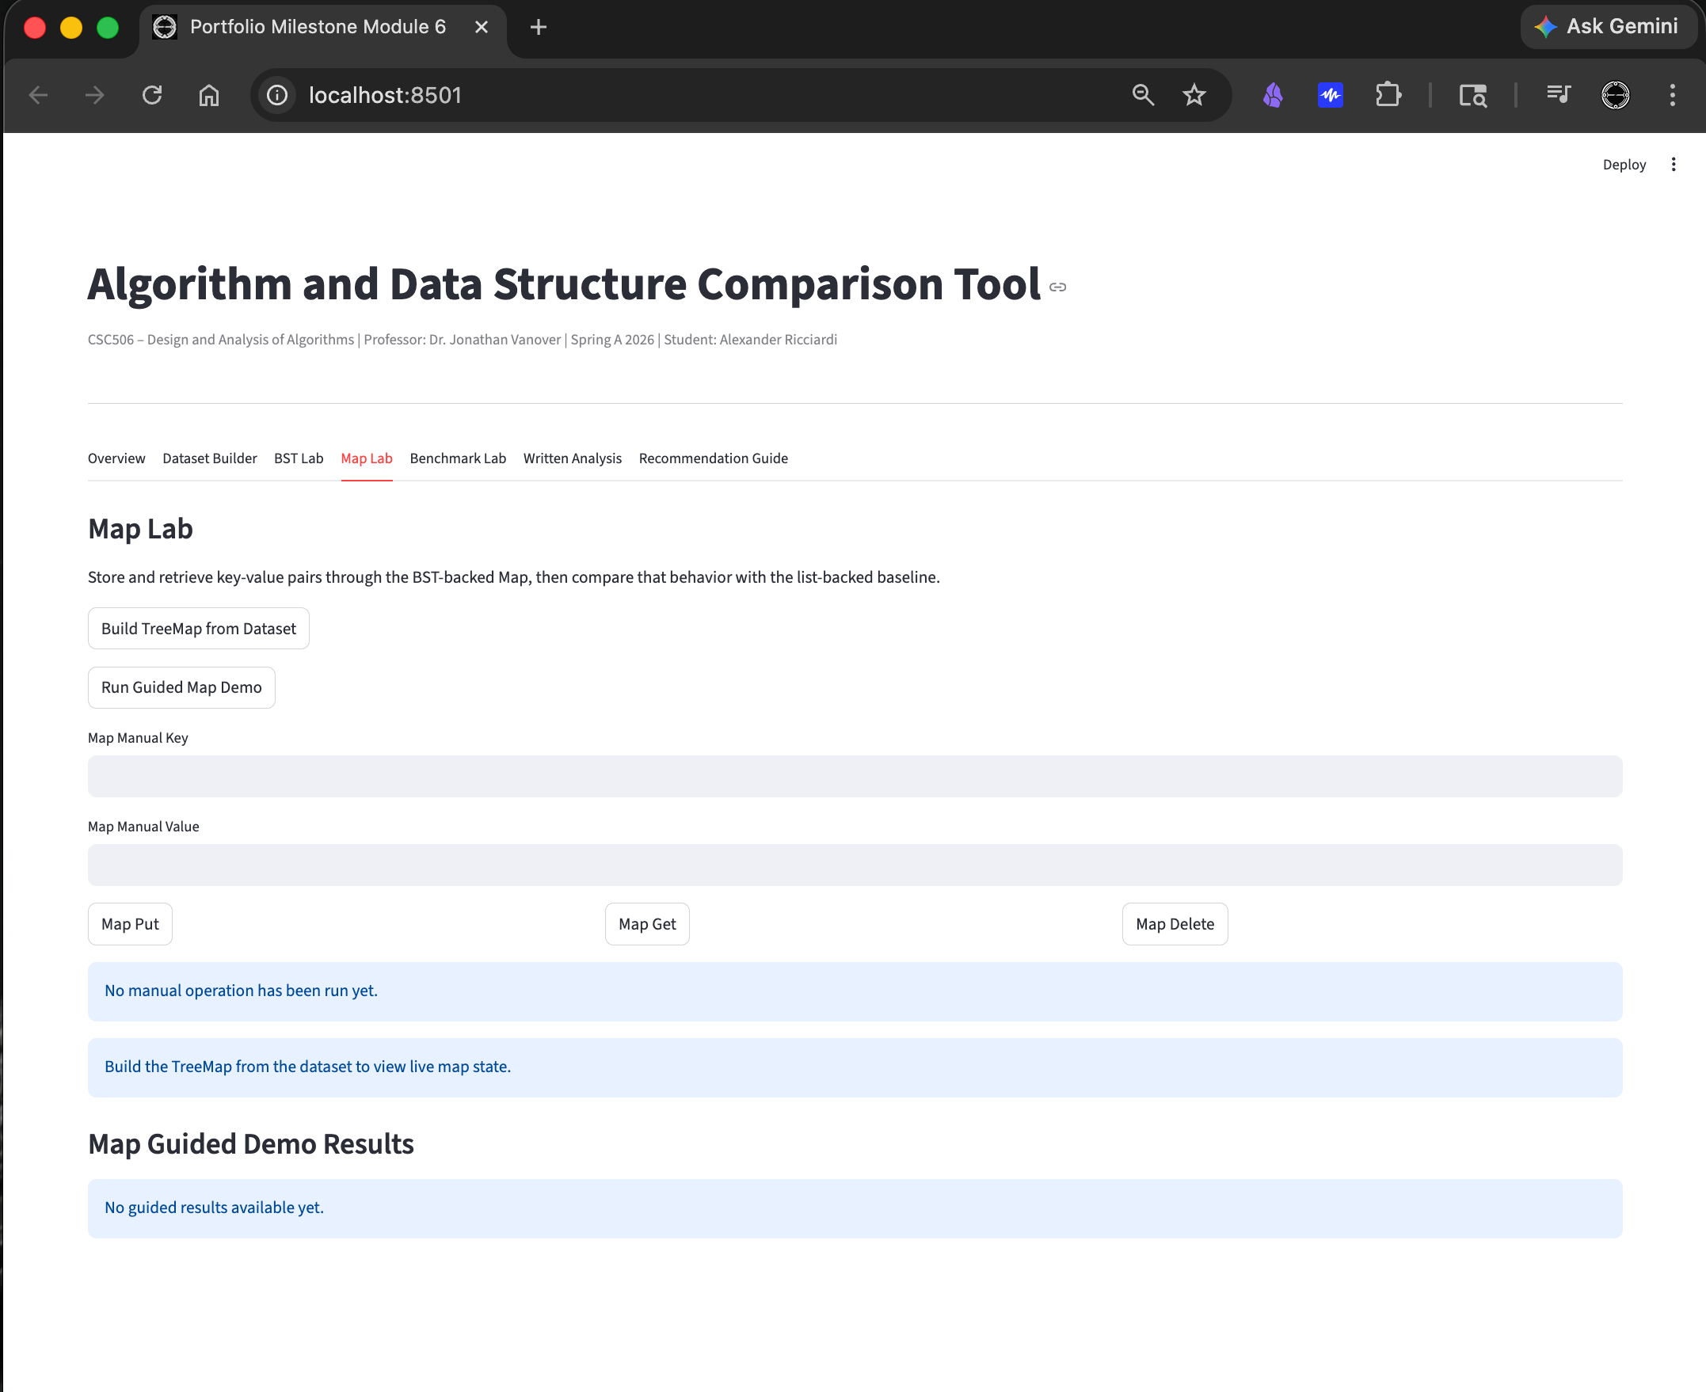

See next page

Map Lab – Build TreepMap from Dataset

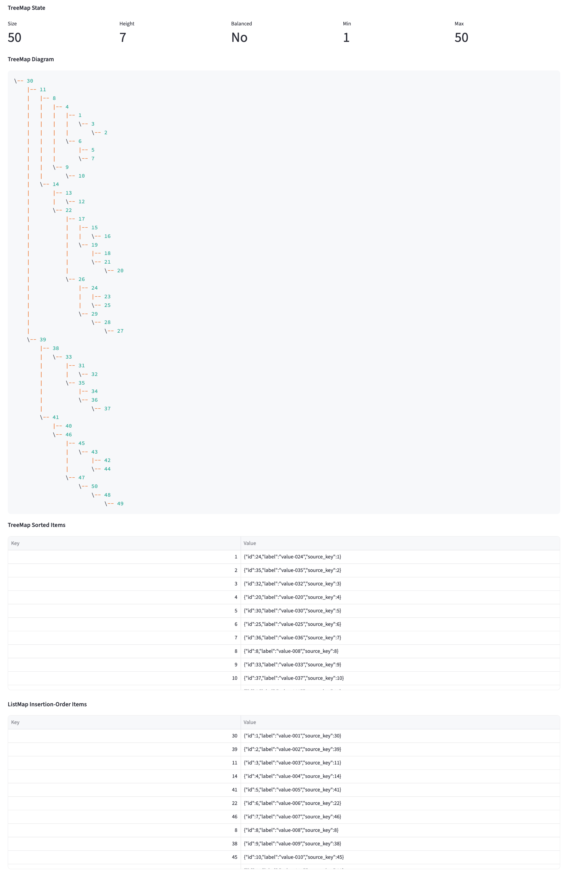

Map Lab – Map Guided Demo Results
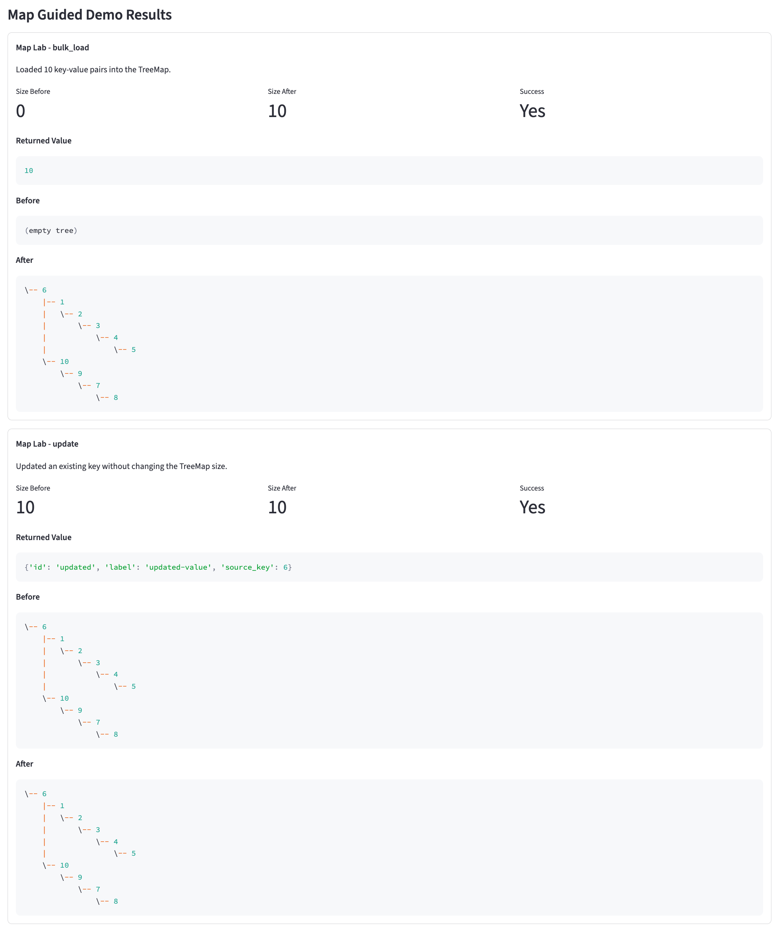
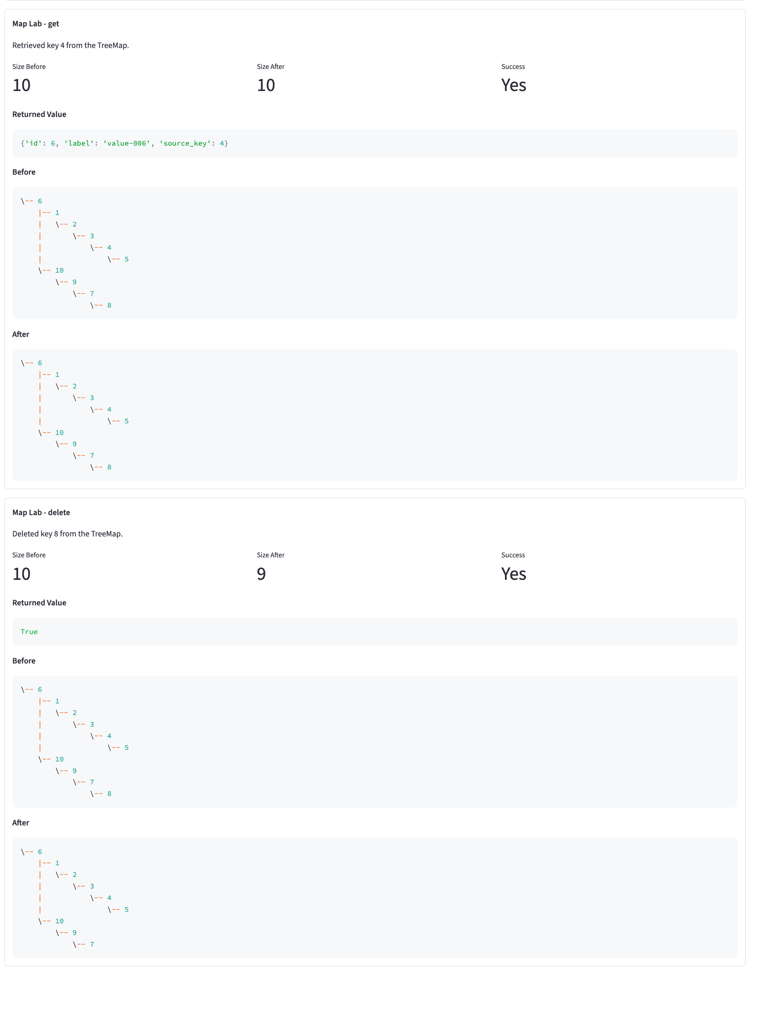

Map Lab – Manuel

Map Put
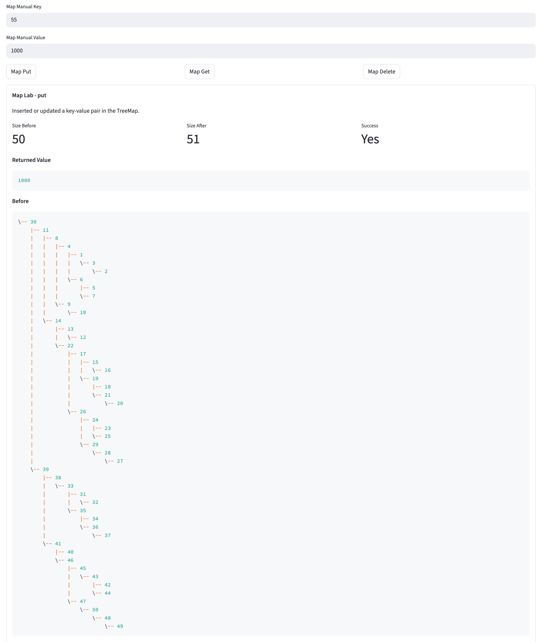
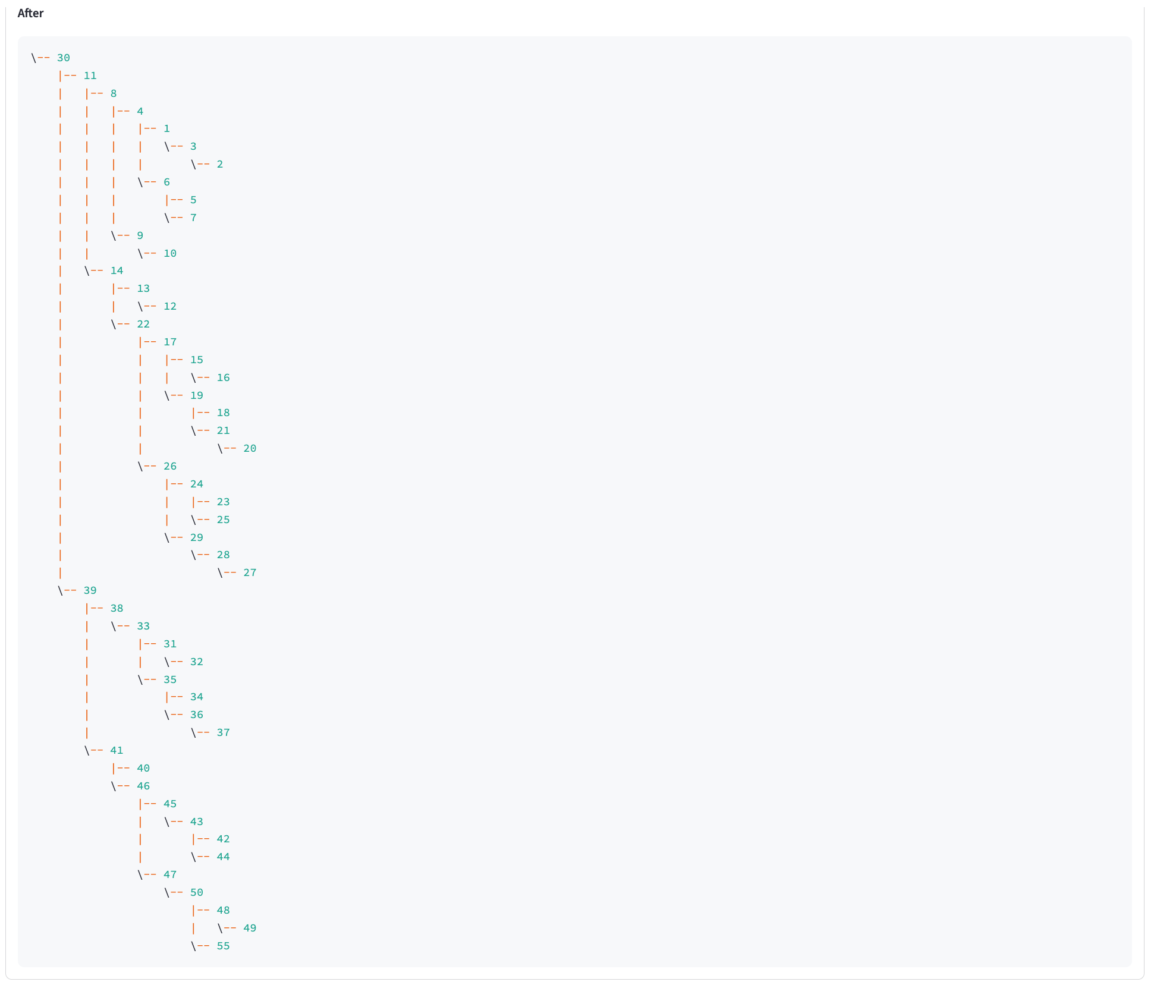

See next page

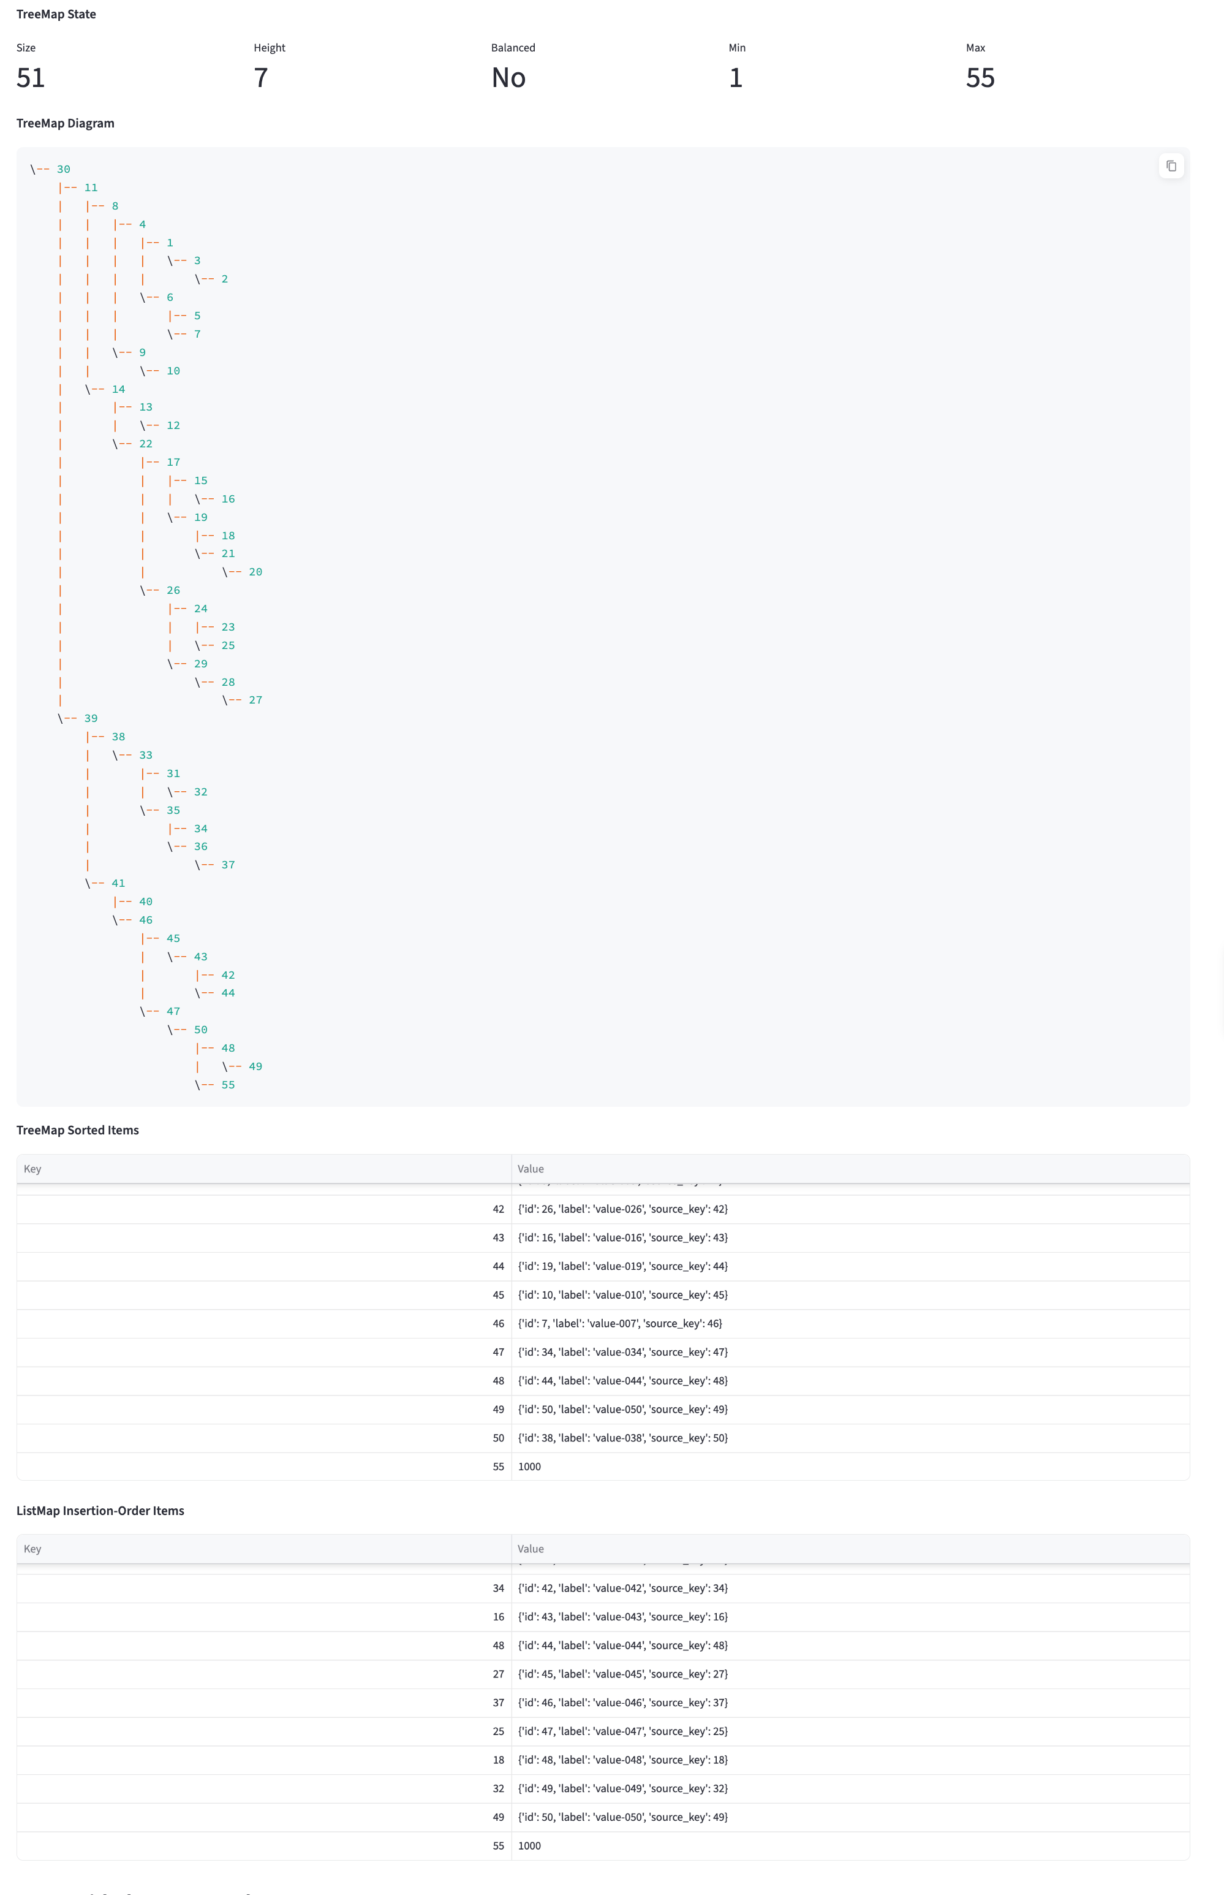

Map get

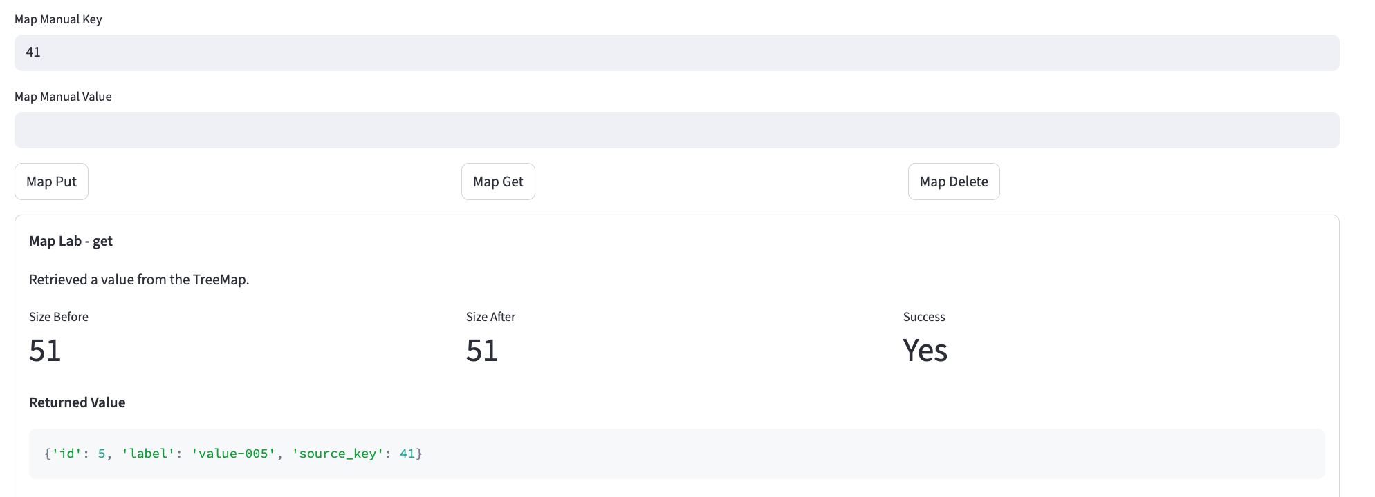

See next page

Map Delete
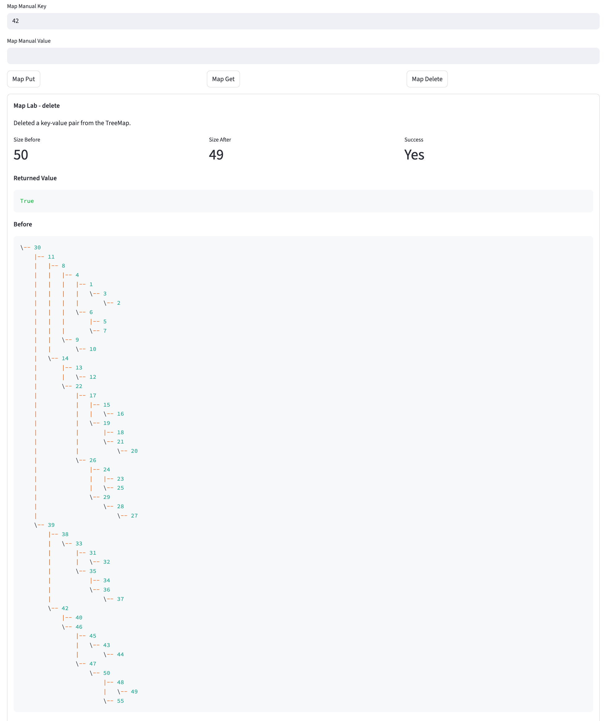
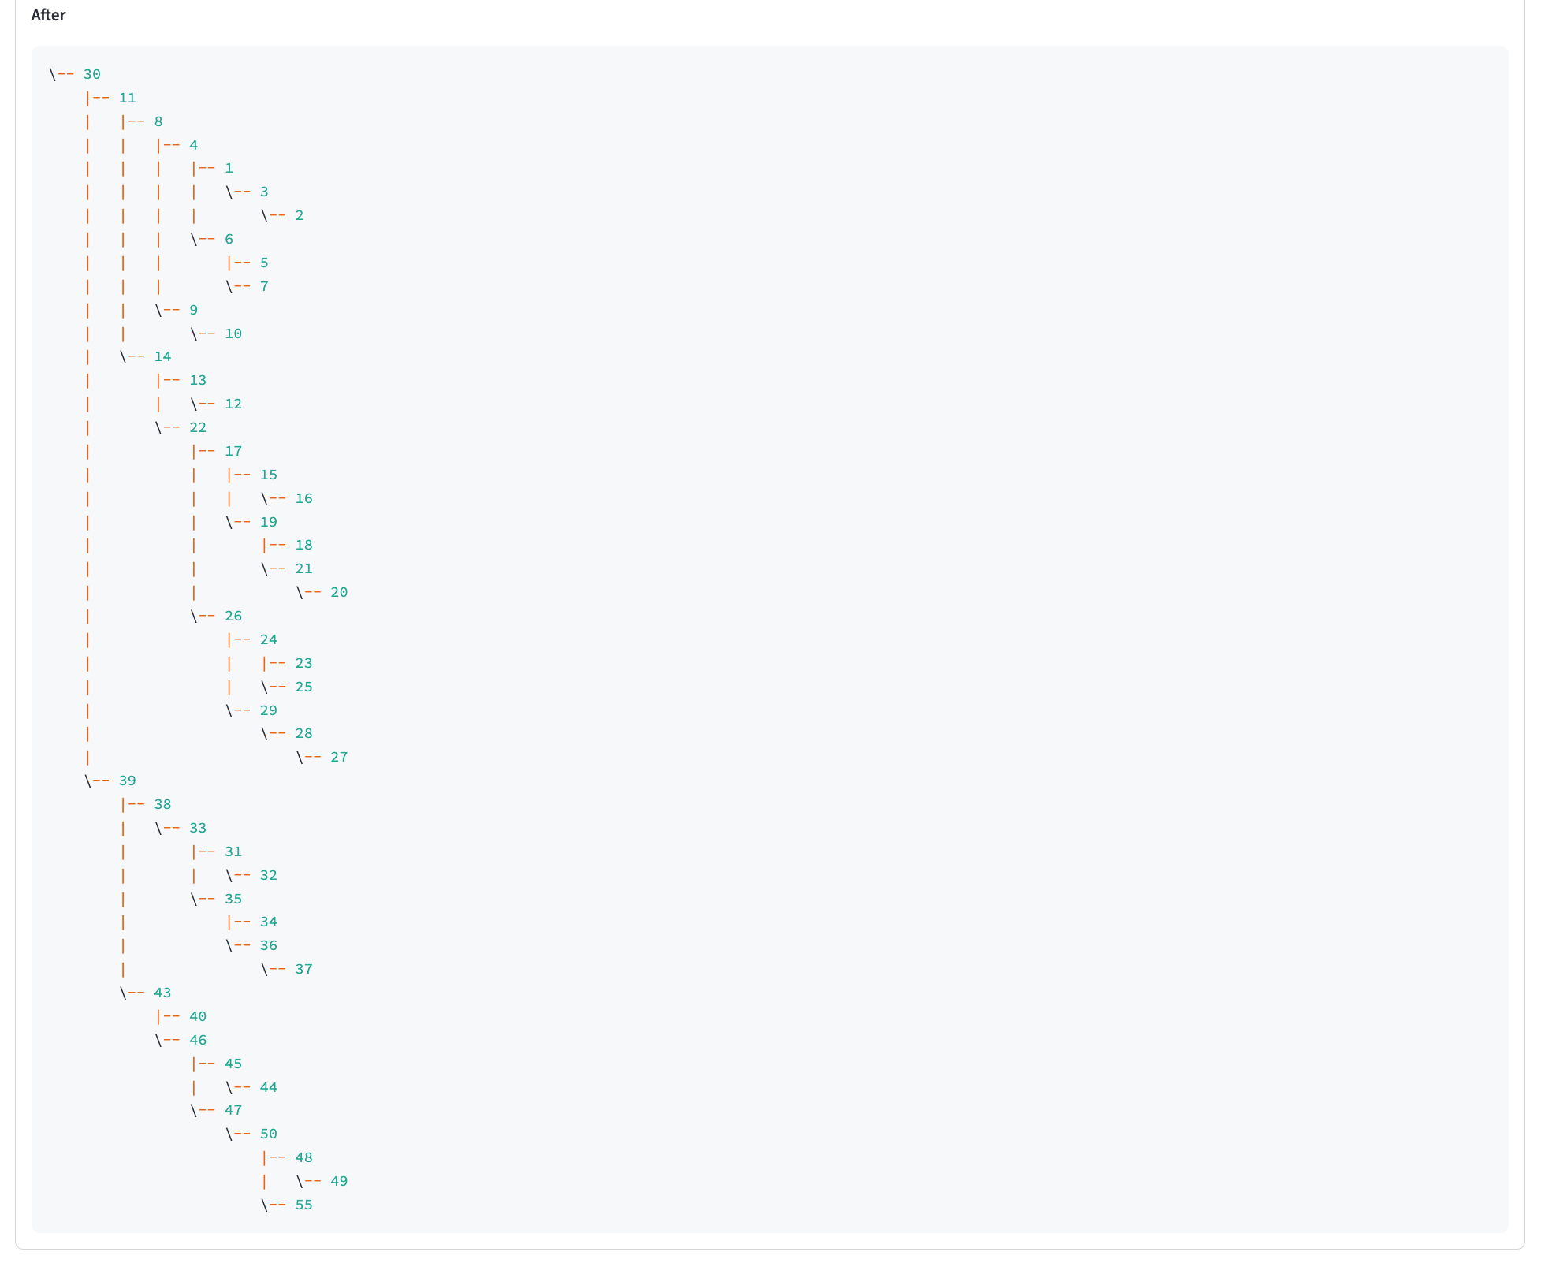

See next page

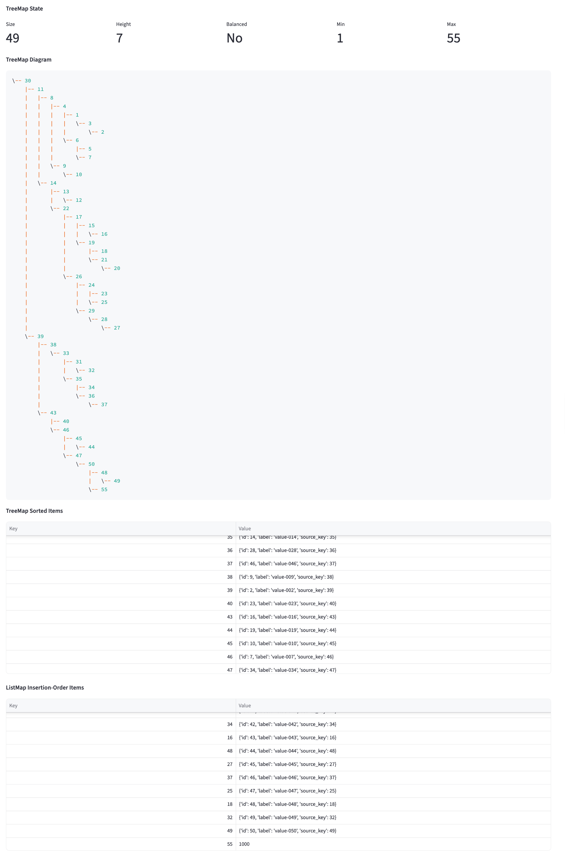

Benchmark Lab

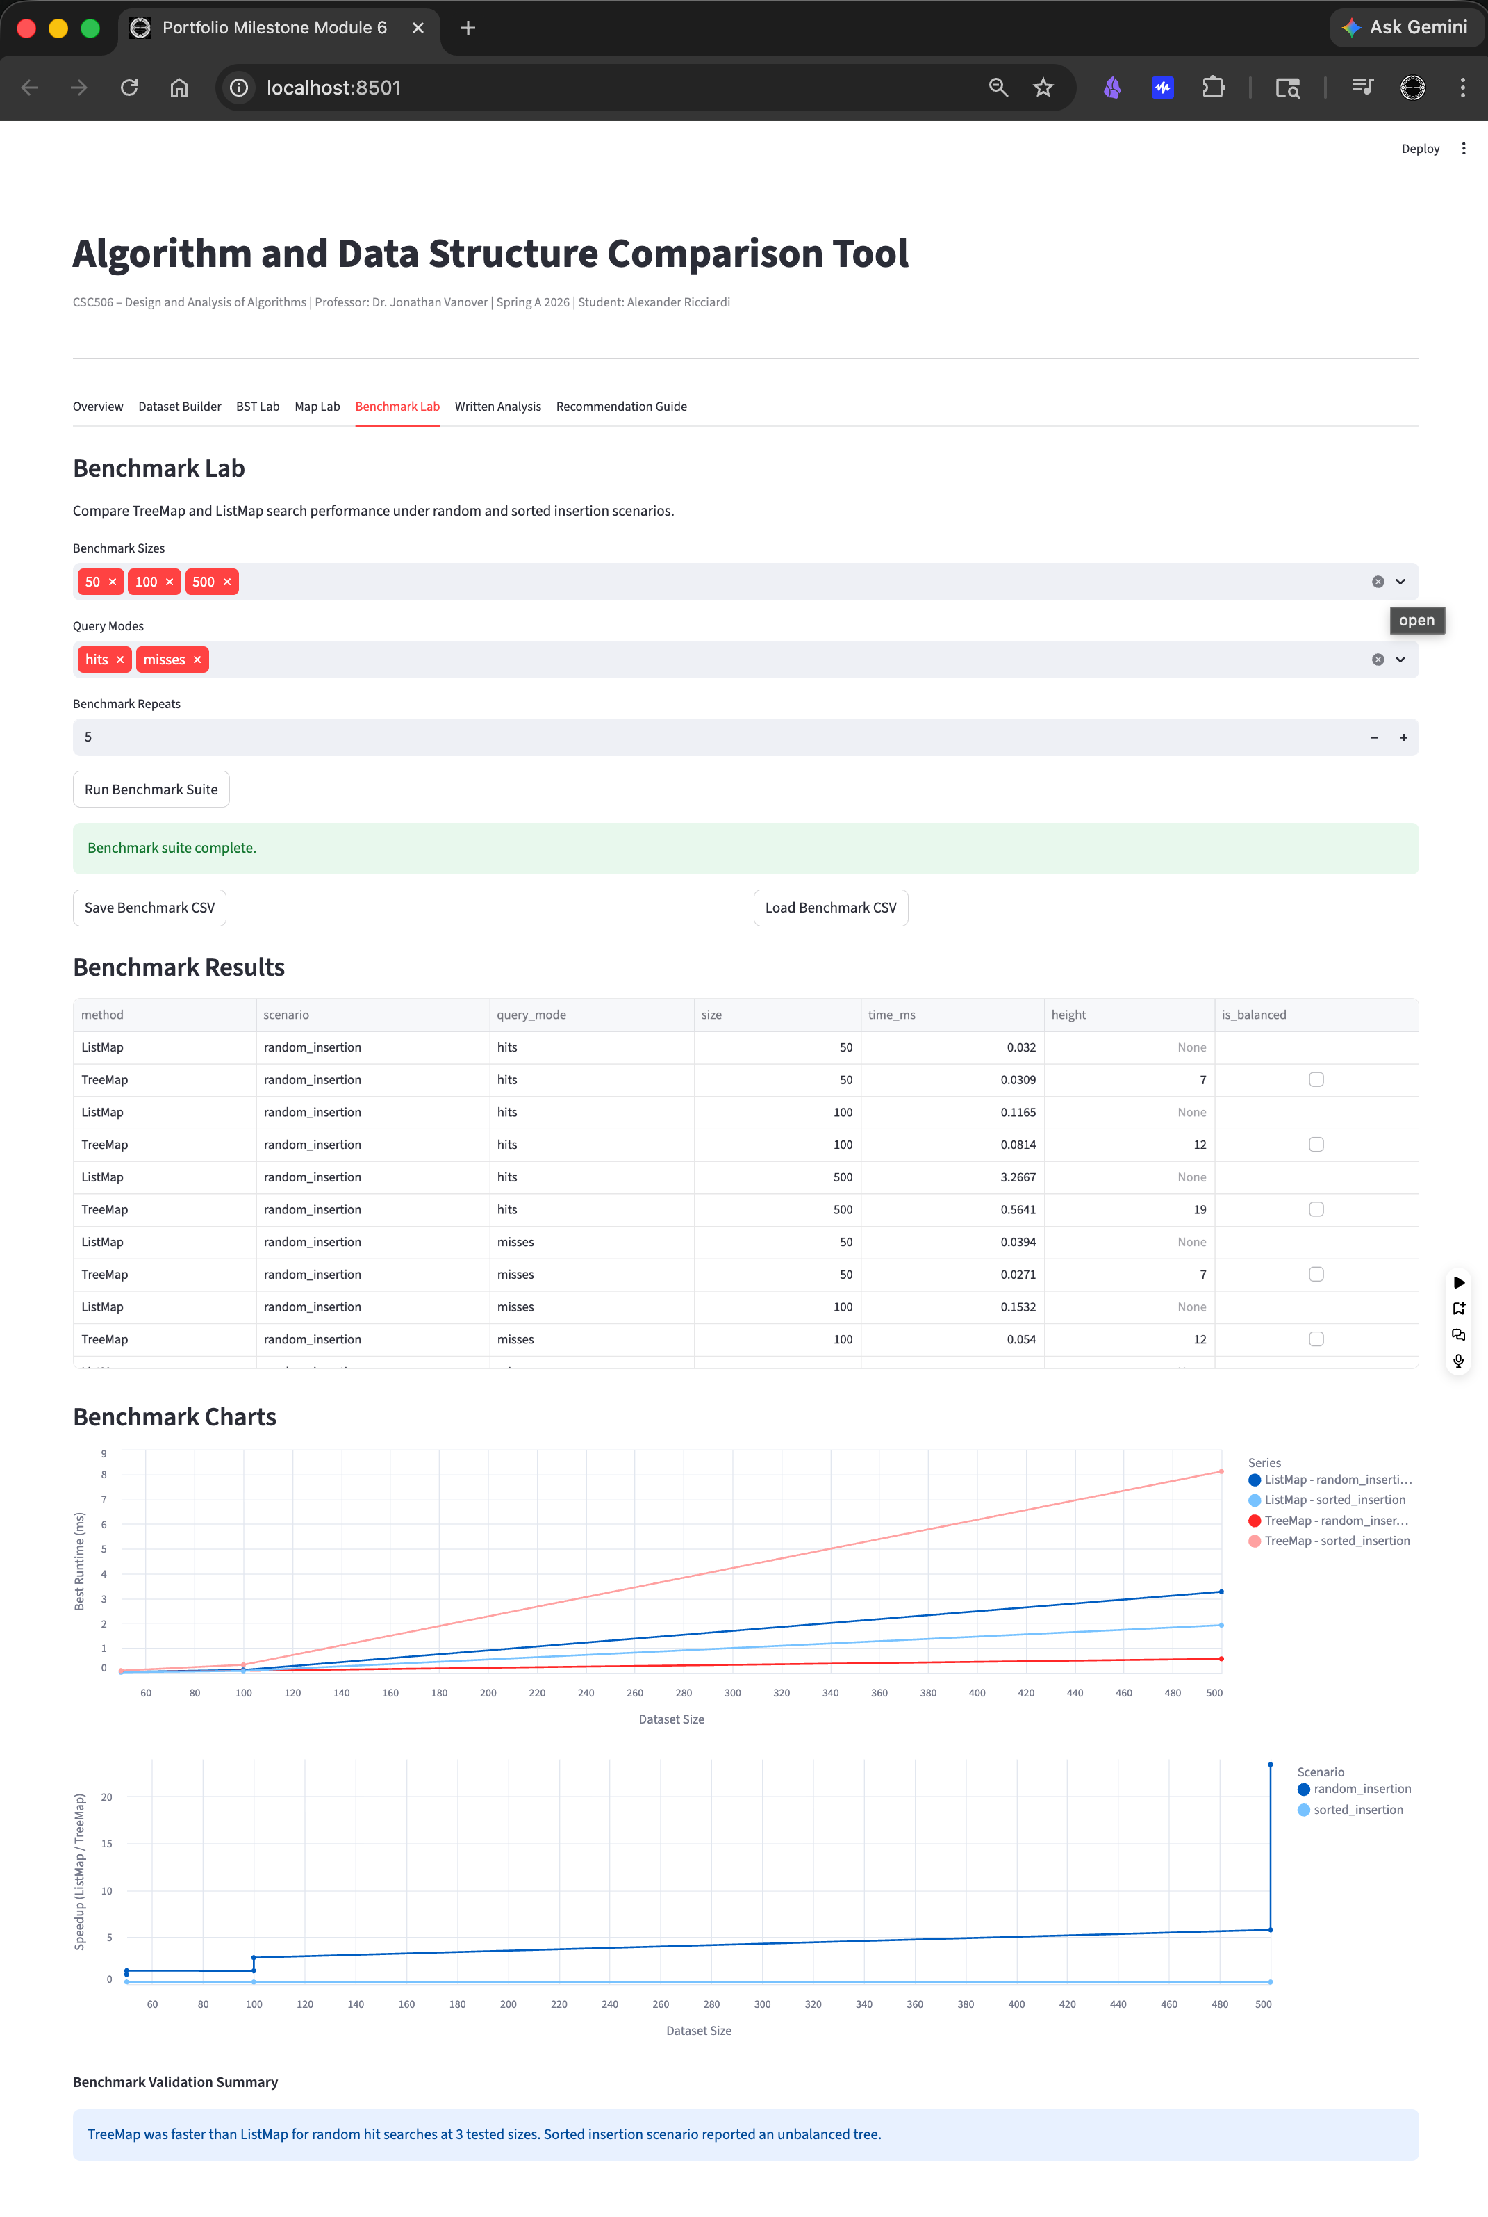

Written Analysis - See written_analysis.docx for full the report
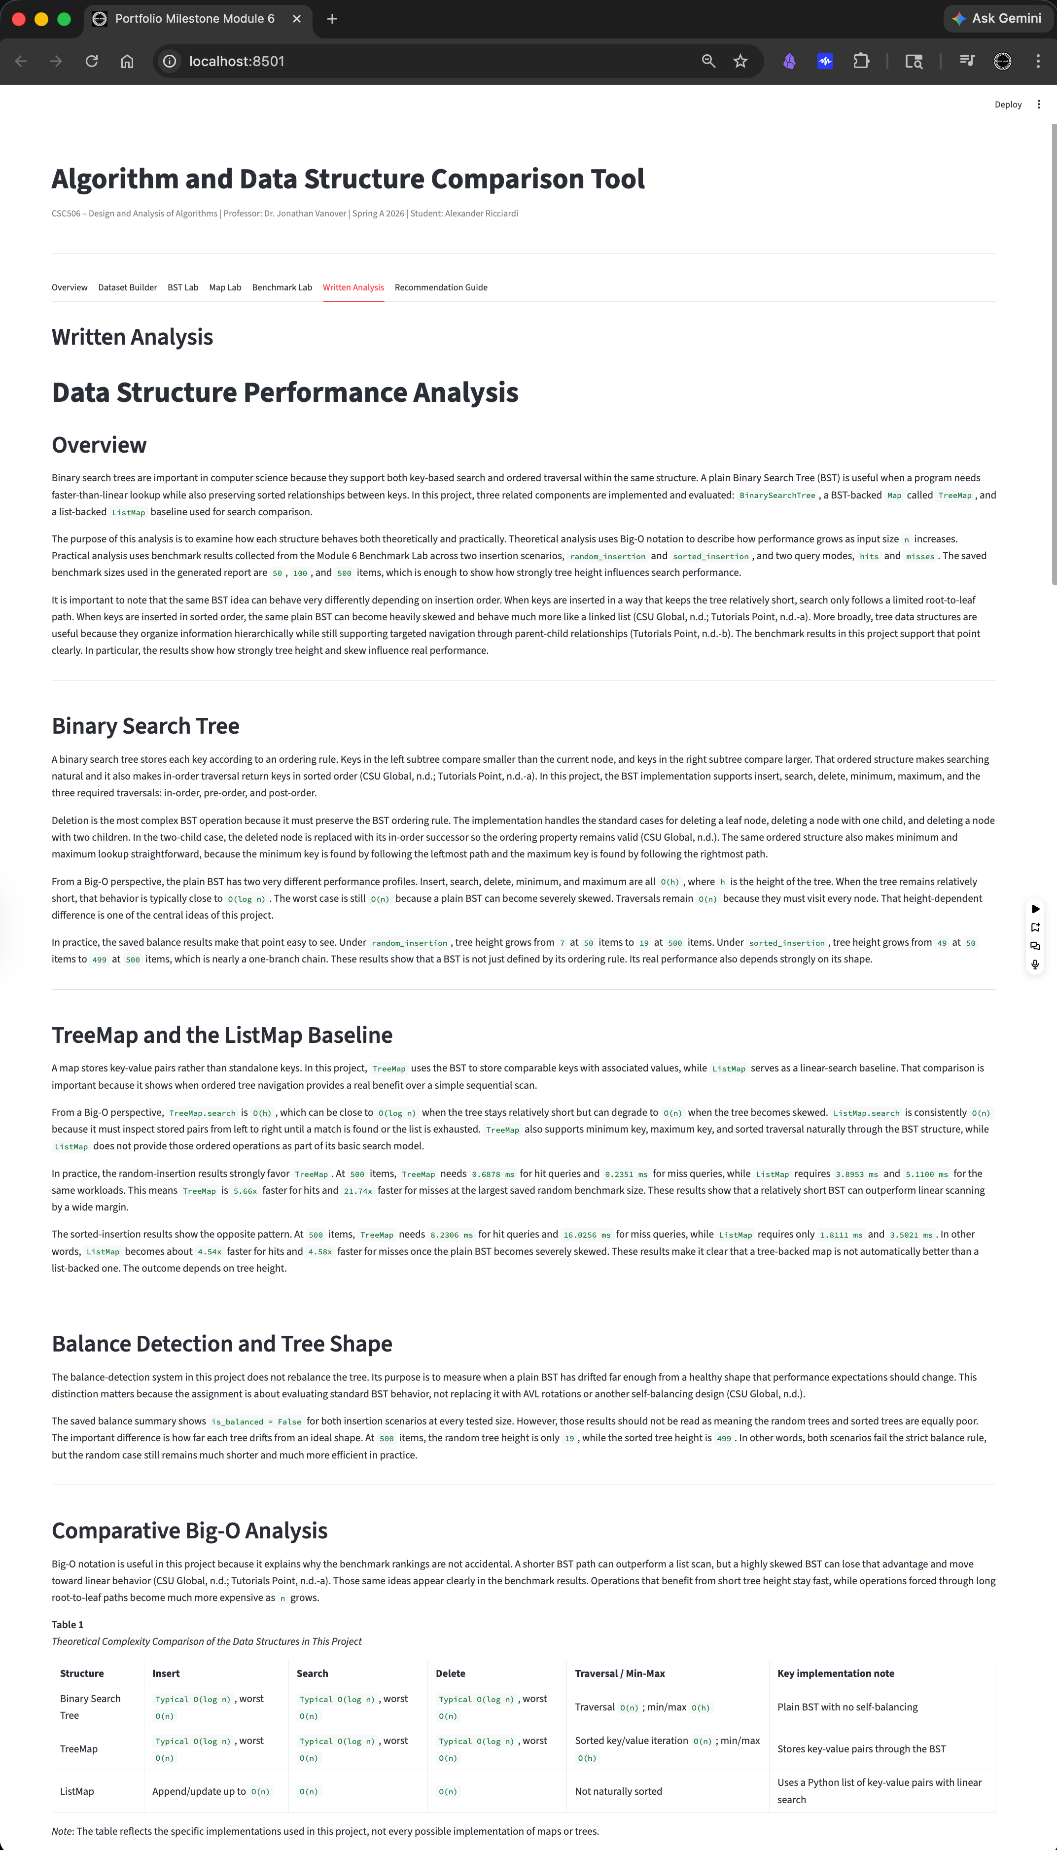

Recommendation Guide – See recommendation_guide.docx for full the report
